

____________ 2020

Dear Parents:

Did you know that your child(ren) can benefit from?:

* Virtual Learning Systems for Students
* Free Extended Year Summer Programs
* Professional Development for Teachers and Principals
* E-Rate Funding for Technology
* Technology Coaches and Online Programs
* School Scholarships and Grants

A portion of the funding for these important educational programs is made available through your hard-earned tax dollars. Every family contributes and every student can benefit, regardless of income level.

**Here’s what you can do to help make sure your children benefit from these resources:**

* Complete the attached family income form IN ITS ENTIRITY and return it to your child’s teacher by **___________**
* Be sure to list the names of all children attending our school on the form

In order to determine the funding available for these programs, we must have an accurate record of family income information. I want to assure you that your privacy will be protected and that the student(s)’ names will be detached from the enclosed form once the necessary information has been recorded. The form will not be shared with anyone and will only be used to determine program eligibility.

Thank you for your cooperation and please do not hesitate to contact me if I may be of further assistance. If you would like additional clarification or information, you may also email Terri Fewel, Assistant Superintendent at the Office for Catholic Schools, at [teresa.fewel@seattlearch.org](mailto:teresa.fewel@seattlearch.org).

Sincerely,

Principal

www.catholicschoolsww.org

*Resources for Parents*

www.ocsww.org

*Resources for Educators*

206-382-4861

1-800-473-5651

710 Ninth Avenue

Seattle, WA 98104

710 Ninth Avenue

Seattle, WA 98104

710 Ninth Avenue

Seattle, WA 98104

**FAMILY INCOME FORM**

* + 1. Indicate the option that describes your family income.

This household size is: _____________

This household monthly income is: ____________

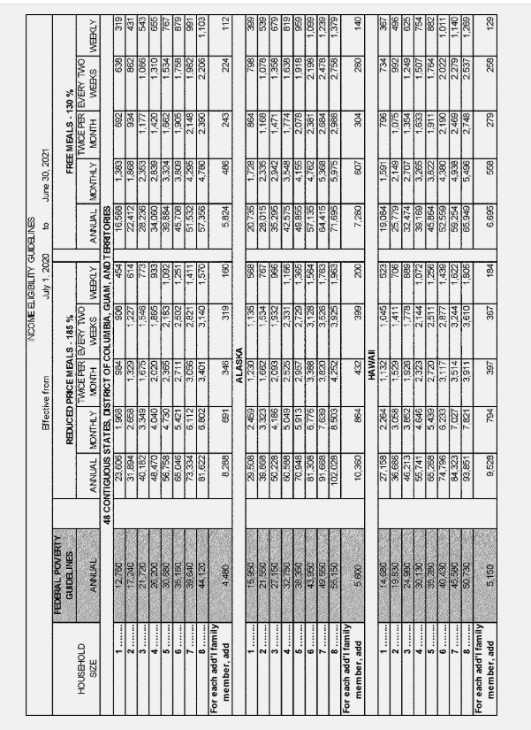

* + 1. Are you receiving assistance under the Temporary Assistance to Needy Families (TANF) program?

Yes _____ No _____

* + 1. Are any of your children eligible to receive medical assistance under the Medicaid program?

Yes _____ No _____

* + 1. What is the name of the public school your child would attend if he/she attended public school?

_____________________________________________________________________________________________________

* + 1. What is the name of your town’s public school district?

_____________________________________________________________________________________________________

* + 1. Home Address (required, please do not indicate a P.O. Box):

_____________________________________________________________________________________________________

City _______________________________________ State________________ Zip______________

* + 1. List the full names of all of the children in your family that attend our school in the spaces provided below.
    2. List the grade levels of all of the children in your family that attend our school in the spaces provided below.

ALL QUESTIONS MUST BE ANSWERED COMPLETELY

To protect your privacy, the student names below will be detached from this form   
once the school records that a family has returned the form.

---------------------------------------------------------------------------------------------------------------------------------------  
Student Name: _________________________________________________ Grade: __________

Student Name: _________________________________________________ Grade: __________

Student Name: _________________________________________________ Grade: __________

Student Name: _________________________________________________ Grade: __________

Student Name: _________________________________________________ Grade: __________