

**ENROLLMENT MANAGEMENT WORKBOOK**

Version 1.0 / September 2014

**TABLE OF CONTENTS – ENROLLMENT MANAGEMENT WORKBOOK**

**introduction 3**

**Why the Workbook Exists 4**

**Resources from the Office for Catholic Schools 5**

**How to Use the Workbook 6**

**creating an enrollment committee 7**

**Principal Selects an Enrollment Lead 7**

**Enrollment Lead Forms an Enrollment Committee 8**

**overview: the work of the enrollment committee 10**

**Sample Enrollment Committee Meeting Agenda for a Full School Year 11**

**committee focus: marketing 17**

**Preparation for Initial Committee Meetings 18**

Set Goals 18

Develop the Purpose and Vision for the Enrollment Committee 20

**Initiating A Robust Conversation 21**

Analyze School Situation & Competition 22

Identify Target Customers 24

Plan Communication 28

Identify The School’s Value Propositions 29

Communicate A Responsible Tuition Strategy 29

**committee focus: recruitment 30**

**Recruitment Principles 31**

**Parent Ambassador Program 32**

Identify Areas of Focus 35

Plan Program Kickoff 42

Invite Attendees 43

Track Results and Celebrate Wins 44

**Admissions Events Guide 45**

**committee focus: retention 50**

**Hosting a State of the School Event 51**

**APPENDIX 53**

**INTRODUCTION**

**OUR COMMITMENT TO ENROLLMENT MANAGEMENT AND MARKETING**

This workbook is a culmination of best practices shared from schools in the Archdiocese of Seattle and across the nation. The Office for Catholic Schools will continually update this workbook as we seek to equip our schools with best practices and to create a culture of collaborative planning.

We challenge you to ask the question “what can we do better together that we cannot do so well alone” and we will hold ourselves to the same challenge.

**Acknowledgements**

The workbook could not have been completed without significant contributions of dedicated Catholic school leaders in the Archdiocese of Seattle, the Fulcrum Foundation, and the following organizations:

National Catholic Educational Association

Alliance for Catholic Education, University of Notre Dame

Office of Catholic Schools, Archdiocese of Chicago

Office for Education, Diocese of Allentown: Office for Education

Catholic School Office, Diocese of Providence

Office of Catholic Schools, Diocese of Arlington

Office of Catholic Schools, Archdiocese of Denver

Office for Schools, Archdiocese of Milwaukee

Office of Catholic Education, Archdiocese of St. Louis

Catholic Schools Office, Archdiocese of Cincinnati

Department of Catholic Schools, Archdiocese of San Antonio

**WHY THE WORKBOOK EXISTS**

The Office for Catholic schools undertook a broad audit of best practices in enrollment management both locally and nationally. We found that at successful Catholic schools, enrollment management is the product of planned local teamwork among principals, teachers, parents, and the broader community. Oftentimes, the process of establishing best practices in enrollment management was born out of an enrollment crisis. Unfortunately, some Catholic schools were not able to react to such a crisis in a timely or suitable fashion. The Enrollment Management Workbook is designed to help all schools, irrespective of their current enrollment standing, to create and execute a plan for enrollment success.

The workbook is a tool that draws wisdom from schools and dioceses all over the country in order to proactively assist leadership in best practice adoption and to promote the value of a Catholic education to prospective families.

**The Enrollment Management Workbook will help the Principal do the following:**

1. Delegate Enrollment Management activities to a committee and Enrollment Lead
2. Provide a roadmap for the Enrollment Lead and committee to institute nationally recognized best practices of enrollment management.
3. Adopt and adapt strategies to the needs, capacities, and culture of their Catholic school.

For successful Catholic schools, action is taken almost each day to support the enrollment management activities of marketing, retention, and recruitment. These practices have become ingrained in a school’s culture and have taken on the unique character of each school community.

At the Office for Catholic Schools, we hope to assist you in adapting the strategies found in this workbook to the needs and realities of your community. We encourage you to contact us and to attend our Enrollment Management Training sessions (see page 5) to help you develop and work the plan for your Catholic school.

**SUPPORTING RESOURCES AND TOOLS FROM THE OFFICE FOR CATHOLIC SCHOOLS**

**ARCHDIOCESAN**

***Enrollment Management Training:***

2014-15 Dates: January 29th, 2015

March 19th, 2015

May 21st, 2015

Each session will be held from 10:00 AM to 12:00 PM at the Isaac Orr conference room at the Archdiocese of Seattle. Training will include steps to develop achievable enrollment targets, how to create and manage enrollment committees, examples of great Parent Ambassador Programs, successful admission event planning, and the retention of current families.

**Catholic Schools Website & Communications:** Beginning fall 2014, a new website will launch to create more access to prospective parents about Catholic education opportunities. Additionally, marketing pamphlets will be delivered to schools and parish communities to develop greater awareness of the Catholic identity, accessible environments, and excellent academic programs found in Catholic schools. All communication resources will be available in English and Spanish.

**Manager for Hispanic Enrollment:** The Archdiocese of Seattle has been awarded a Strategic Grant from the Catholic Campaign for Human Development (CCHD) for a new position in 2014-15. Schools interested and able to improve Hispanic enrollment will receive assistance in efforts to understand, engage, and enroll more Hispanic families. When hired, the manager will provide assistance in the creation of alliances within the Hispanic community, help to develop enrollment-focused teams, create outreach materials, and provide strategic guidance.

**REGIONAL**

***Consultation Services:*** As needed, the Assistance Superintendent of Enrollment Management is available to attend both regional and local meetings to help schools develop enrollment targets, form effective committees, start or improve Parent Ambassador Programs, hold successful admissions events, provide guidance in website development, and work to retain a school’s current families. Call or email Tim Hunt. (206)747-5351 [tim.hunt@seattlearch.org](mailto:tim.hunt@seattlearch.org)

**LOCAL**

***School Snapshot***: A collection of data specific to each school that are useful in developing a strategic enrollment target for the year. Information includes the basic operational data of a school, responses from the most recent Marketing Resource Survey (OCS), demographic information from a school’s surrounding area (age, race, Catholic, non-Catholic, and average income), enrollment history, local baptism information, and suggested enrollment management goals from the OCS. A custom snapshot is provided confidentially to each school principal by the OCS.

***Enrollment Management Workbook:*** A collection of best practices in Enrollment Management (marketing, recruitment, and retention) for Catholic schools. The workbook provides in depth guidance to assist schools in developing enrollment committees, creating Parent Ambassador Programs, hosting successful admissions events, and strategies to retain current students.

**HOW TO USE THE ENROLLMENT MANAGEMENT WORKBOOK**





**SETTING UP YOUR TEAM**

**PRINCIPAL SELECTS AN ENROLLMENT LEAD**

Each school needs a dedicated Enrollment Lead to ensure that consistent enrollment management actions are planned and taken. **The Enrollment Lead reports directly to the Principal and is responsible to:**

* Develop, review, and enhance the annual school enrollment plan
* Manage and direct an effective enrollment committee
* Plan and coordinate admissions events and other opportunities to get new families on campus
* Recruit, motivate, and direct parent volunteers
* Integrate best practices related to marketing, recruitment, and retention into the annual activities of the school
* Act as an ambassador for the school to the broader community
* Attend Marketing and Enrollment Management Workshops provided by the OCS

A task oriented Enrollment Lead can develop and lead a committee of action oriented members, through the following Enrollment Management Workbook to develop the school’s local plan. This committee may include the Principal, pastor, school commission members, and volunteers. An Enrollment Lead must believe in the mission of the Catholic school, understand the history of the community, and positively lead community collaboration for a well-functioning enrollment management program.

To ensure that the school is prepared to welcome new families and to follow up on inquiries, enrollment should ideally be managed by a full-time staff position. If this is not possible, the Principal should consider assigning responsibilities to an existing staff member (e.g., a Marketing Director or Development Director), sharing a position with another school, or hiring someone on a part-time basis. The least preferred option is to enlist the help of a volunteer who may have the skill to manage an Enrollment Committee and plan but will likely not have the time or availability that are needed.

A full **sample** **job description** for an Enrollment Lead is located in the Appendix.

**ENROLLMENT LEAD FORMS AN ENROLLMENT COMMITTEE**

**One of the chief responsibilities of the Enrollment Lead is the creation and management of an Enrollment Committee.** This committee is ideally a sub-committee of the School Commission, supporting its responsibilities as outlined in the School Commission Handbook, such as “providing optimal public relations,” “developing a plan and means to finance school programs,” and “establishing a mission statement and strategic plan.” The School Commission and the Enrollment Committee differ in function in that the School Commission advises school leadership on many matters, while the Enrollment Committee implements the school’s plan.

**The Enrollment Committee will focus on** **the ecosystem of enrollment management: marketing, recruitment, and retention**. The illustration below provides a broad overview of the work of the committee; the rest of the workbook includes a sample agenda for a year’s worth of committee work, specific examples of best practices, and supporting templates. The workbook is designed to keep an Enrollment Committee focused and to save the Enrollment Lead valuable time.



The Enrollment Committee is primarily responsible for overseeing the Principal components of the plan, which include:

* Analyzing the school’s enrollment data to identify areas of need and focus.
* Developing the school’s planned calendar of school enrollment activities.
* Planning, managing, and staffing events for recruitment and retention.
* Increasing enrollment through effective communication to target markets and personally following up with families that show interest in enrolling.
* Training ambassadors in the community to positively represent the Catholic school.

**SETTING UP YOUR TEAM**

**School Leaders:**

* Must include: Enrollment Lead and Principal
* Might include: Pastor, outstanding teacher(s), and other staff

Responsibilities:

* Help to set the committee agenda and deadlines, ensuring execution of events and preparing the school for planned and unplanned visits from potential families.
* Promote faculty culture of enrollment friendly practices, including the creation of a welcoming environment for all.
* Assess current family satisfaction in real-time.

**Professionals:**

* Might include: People with talent and experience in marketing, public relations, and general business or non-profit work; technical professionals with experience in website development, graphic design or database management, sales people and finance professionals.

Important Skills:

* Possess strong written and verbal communication abilities
* Able to bring the perspective of parents in developing the value proposition
* Able to interpret data and develop strategy

**Organizers:**

* Might include: People with strong attention to detail, schedules, deadlines, and coordination of people and resources.

Important Skills:

* Bookkeeping
* Budgeting
* Event planning
* Systems analysis

**Connectors:**

* Might include: Natural word-of-mouth promoters, determined to get new families on campus and passionate about Catholic schools, for example: Parents, grandparents and parish staff.

Important Skills:

* Well-connected in the community
* Able to recruit and motivate volunteers
* Able to make friends easily
* Possessing persuasion and advocacy skills

**ENROLLMENT COMMITTEE OVERVIEW**

**THE WORK OF THE ENROLLMENT COMMITTEE**

With as much detail as possible, the workbook is intended to help a new Enrollment Committee immediately develop and work a plan that will improve enrollment at their school. The following pages contain best practices collected from schools in the Archdiocese of Seattle and from across the nation. By following the “how to’s” provided, the Enrollment Committee can develop a strategic plan for the year to recruit prospective families on campus and to get them enrolled. Effective use of the workbook should also create a deeper loyalty among current parents who will remain at the school and become passionate advocates to prospective families.

The workbook proceeds chronologically through the three emphases of a complete ***enrollment management ecosystem:***

**Marketing:** The marketing section lays the groundwork for each subsequent section. Initial committee meetings include honest and robust conversation about the current state of the school, the advantages of the school compared to other education options, the potential for recruitment in the school’s catchment area, the main reasons that existing parents choose the school, and why others may not. After finishing this section, the Committee should understand why the school is worth promoting and how it delivers value to members of the school community.

**Recruitment:** The recruitment section includes examples of what can be done over the course of the year to improve enrollment, including the development of a Parent Ambassador Program and the hosting of multiple Admissions Events. The committee should set a calendar of recruitment events for the year and ensure that proper follow up occurs outside of committee meetings: For example, the school should project a welcoming attitude, keep track of families who show an interest in the school, and follow up according to a plan.

**Retention:** Retention is a strong measure of a family’s satisfaction with the school and a focus on improving retention is an important way to maintain the gains of the enrollment management plan. To ensure that existing families are re-enrolling for the next year, effective retention strategies should be planned during committee meetings, and action should be taken outside of these meetings. Other retention strategies are included in this workbook for schools to incorporate into their retention practices.

**SAMPLE ENROLLMENT COMMITTEE MEETING AGENDA FOR A FULL SCHOOL YEAR**

The following section contains sample agenda for the phases of planning and execution that help schools develop local enrollment management plans. The agenda are organized with the assumption that a school is only now addressing marketing, recruitment, and retention in a comprehensive manner, but are also adaptable for schools looking to improve current practices.

Supporting each phase of committee agenda are “Committee Focus” areas, outlining in greater detail the work of the Enrollment Committee. It is highly recommended that both the Principal and Enrollment Lead gain a familiarity with the elements of this workbook and create agenda for the school year before the first meeting of the Enrollment Committee.

**Phase 1: Current Situation Analysis and Goal Setting**

**Phase 2: Parent Ambassadors**

**Phase 3: Driving Admissions & Handling Objections**

**Phase 4: Ensuring Retention of Current Students**

**Phase 5: Ongoing Progress Evaluation and Plan Optimization**

**Phase 1: Current Situation Analysis and Goal Setting**

*Expanded discussion of phase 1 topics found in the “Committee Focus: Marketing” section.*

This initial phase will require the greatest amount of preparation, attention, and follow up compared to all other phases. In order to set the foundation for Enrollment Committee success, it is advised that the Enrollment Committee meet frequently over a short period of time to complete this phase, leaving ample time for subsequent meetings.

**Pre-Meeting Preparation:**

* Principal selects an Enrollment Lead. (page 6)
* Enrollment Lead reviews the workbook content and plots out Enrollment Committee meetings and enrollment management milestones for the year.
* Enrollment Lead and Principal set the school’s Enrollment Targets for the year, leveraging the Snapshot and Enrollment Tracking Spreadsheet. (See Appendix for blank templates and Committee Focus: Marketing section for examples)
* Enrollment Lead sets a preliminary committee agenda to cover marketing, recruitment, and retention. (Sample Agenda pages 11-15)
* Enrollment Lead personally invites prospective Enrollment Committee members.
* Blank copies of both the Value Proposition, SWOT Analysis, Communication Map, and Audience Profile worksheets are printed for distribution at appropriate times in the meeting (See Appendix for worksheet templates).

**Agenda for Meeting(s):**

1. Vision for School and Enrollment Committee Shared by Leadership
2. Introduction of Enrollment Committee Members
3. Situation Analysis
   1. School History and Current Status
   2. Enrollment Data
   3. Demographics of Current Families
4. Work Session
   1. SWOT Analysis
   2. Value Proposition Development
   3. Target Audiences
   4. Communication Plan
5. Develop Calendar of Recruitment and Retention Events for Year

**Follow up work by Lead:**

* Follow up with committee members on any tasks delegated during meetings.
* Ensure completion of the worksheets used during committee meetings (see Appendix).
* Refine calendar of recruitment and retention activities.

**Phase 2: Parent Ambassadors**

*Expanded discussion of Parent Ambassadors found in the “Committee Focus: Recruitment” section.*

**Pre-Meeting Preparation:**

* Refine calendar of recruitment and retention events.
* Review Parent Ambassador Program and associated templates in Recruitment Section and Appendix.
* Principal and Enrollment Lead determine Parent Ambassador Areas of Focus for year.

**Agenda for Meeting(s):**

1. Introduce Parent Ambassador Program
2. Propose, discuss and select areas of focus for Parent Ambassadors
3. Create game plan and assign responsibility for recruiting Parent Ambassadors
4. Discuss sample calendar of events for the year, ensure that timing works for committee members including the Parent Ambassador Kickoff Event.

**Follow up work by Lead:**

* Check in with committee members on Parent Ambassador recruitment efforts.
* Track recruitment progress.
* Plan the first Parent Ambassador meeting agenda and content.
* Begin sending invitations for first meeting of the Parent Ambassador Program.

**Phase 3: Driving Admissions & Handling Objections**

*Expanded discussion of Admissions Events found in the “Committee Focus: Recruitment” section.*

**Pre-Meeting Preparation:**

* Review admissions progress to date and share successes.
* Refine calendar of recruitment and retention events.

**Agenda for Meeting(s):**

1. Re-visit calendar of recruitment and retention events for the year
2. Discuss resources needed for events such as signage, marketing packets, FAQ sheets, tour guides, and registration forms
3. Brainstorm strategies to ensure new families attend planned events
4. Create answers to frequently asked questions and common objections from prospective parents.

**Follow up work by Lead:**

* Adjust and update Admissions Events as necessary.
* Begin preparing resources for events – consider both materials and staffing.
* Ensure that event staff receives proper training to confidently answer frequently asked questions and common objections.
* Reach out to prospective parents when appropriate. Consider various channels of communication that may make sense for who you are trying to attract.

**Phase 4: Ensuring Retention of Current Students**

*Expanded discussion of phase 4 topics found in the “Committee Focus: Retention” section.*

**Pre-Meeting Preparations:**

* Refine calendar of recruitment and retention events.
* Plan, in greater detail, a retention program for the school year.

**Agenda for Meeting(s):**

1. Understand retention goals set by Principal and Enrollment Lead
2. Discuss primary points of gains and losses
3. Create content and timing of communication to current families
4. Discuss when and how to execute re-enrollment for best results

**Follow up work by Lead:**

* Plan and execute ongoing communications with current parents.
* Create materials for answering common re-enrollment objections and concerns.
* Lead Re-enrollment efforts and staff training.

**Phase 5: Ongoing Progress Evaluation and Plan Optimization**

*The Enrollment Lead is responsible to evaluate the year’s enrollment management activities. It is critical that the Enrollment Committee celebrate any progress to goal, even if an enrollment target is not met. Enrollment management is only effective when it receives proper attention and energy.*

**Pre-Meeting Preparations:**

* Prepare a recap of the year’s progress.
* Plan a year-end event, to thank the Enrollment Committee for time and effort.
* Acknowledge and celebrate success stories and articulate goals for the coming year that will ensure continued success and address opportunities for continued growth.
* Prepare to personally ask each committee member to be a part of the team again during the next school year. If committee members are unable to attend, reach them via phone.

**Agenda for Meeting(s):**

1. Year-End Review
   1. Progress to Goal
   2. Celebrate Successes and Acknowledge Leaders
      1. Strategic Planning
      2. Good News Stories (Enrollment Growth or Value Propositions)
      3. Parent Ambassadors
      4. Admissions Events
      5. Re-Registration
   3. Prepare for the next year
      1. Discussion of what will be required for ongoing success
      2. Honest assessment of any challenges and opportunities for growth

**Follow up work by Lead:**

* Capture and record areas to improve and to build
* Begin planning process for next year

**COMMITTEE FOCUS: MARKETING**

This Committee Focus section sets an important foundation for all school activities related to local enrollment management. **The amount and importance of the work in the Marketing section requires multiple meetings occurring over short period of time.** This will be important to bring an effective Enrollment Committee up to speed and develop the necessary momentum to execute the school’s plan.

After completing this section, the Enrollment Committee will:

* Understand leadership’s vision for the future of the school.
* Know a school’s current situation (including strengths, weaknesses, opportunities, and threats) and create an enrollment management plan with a specific target for growth.
* Appreciate reasons current parents enroll and why prospective parents should as well.
* Develop a comprehensive communication strategy to current and prospective families.

Tools and resources available for the Enrollment Lead:

* HIGHLY RECOMMENDED: Designate a committee member to record meeting minutes
* School Snapshot (additional copies available through the Office for Catholic Schools)
* Worksheets found in the Appendix:
  + Enrollment Target
  + SWOT Analysis
  + Audience Profile
  + Communication Map
  + Value Proposition
* The school’s most recent accreditation documents can also be a very helpful resource.

**PREPARATION FOR INITIAL COMMITTEE MEETINGS**

The marketing section requires that the Enrollment Lead facilitate a robust conversation and elicit productive feedback from committee members. Before initiating this conversation, it will be important for the Enrollment Lead to review the Enrollment Management Workbook in its entirety with the Principal. This will help leadership develop a reasonable Enrollment Target and plan a calendar of activities to reach that target.

**Goal Setting**

Schools are encouraged to set an Enrollment Target that can be reasonably achieved and that can be met while maintaining a high level of service. For example, just because a school facility has capacity to accommodate an additional 100 students, it may be unwise to set such a goal without consideration of additional staff hires needed to maintain proper attention to each student.

When setting the target for a year, the **Enrollment Target Worksheet** can be a helpful tool to anticipate different factors such as the current enrollment, graduating students, and transferring students to determine the actual number of new students needed.



*A blank Enrollment Target Worksheet is located in the Appendix.*

In the example above, St. Catholic School hopes to grow total enrollment by 10 students. After considering the number of current students that will be lost to graduation and transfers, the actual number of new students required to reach the Enrollment Target is brought to 38. Take notice of the potential revenue growth of 10 additional students in the next school year.

The **School Snapshot** can also be helpful in developing an Enrollment Target. The Snapshot includes a map of the school’s surrounding region and associated demographic information (e.g., age, race, Catholic and non-Catholic), history of local parish baptisms, as well as school enrollment history since 2008. Finally, the Snapshot lists suggested goals in order of importance. While a school may have many suggested goals on their annual Snapshot, it is recommended that a committee focus only on 2-3 goals each year to reach the Enrollment Target.

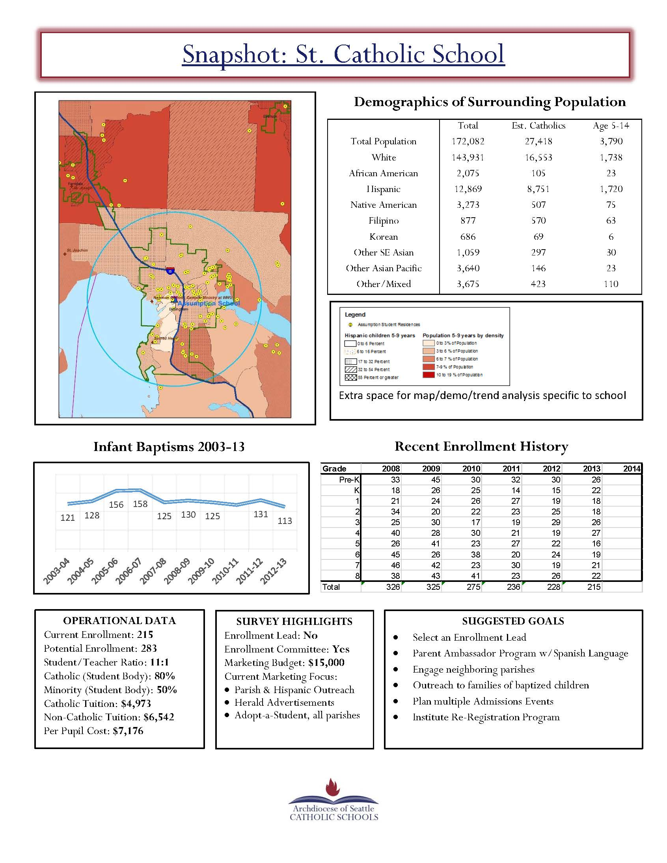

***The Snapshot is available through the OCS, please contact the Asst. Superintendent for Enrollment Management and Marketing for assistance in setting reasonable and achievable Enrollment Targets.***

**Develop the PURPOSE and VISION for the Enrollment Committee**

***IMPORTANT: to be completed by Principal, Enrollment Lead, and (when appropriate) Pastor.***

Prepare to communicate the purpose and vision for the Enrollment Committee as the first agenda item at the very first meeting. It is not only important to avoid overthinking this step, but to also not underestimate the importance of communicating that there is indeed a purpose and vision for the Enrollment Committee. It is encouraged that the Enrollment Lead speak in both simple and aspirational terms when describing purpose and vision.

**The simple purposes of the Enrollment Committee include:**

* Developing greater awareness about the school’s value
* Increasing and sustaining the school’s enrollment
* Instituting nationally recognized best practices for enrollment and marketing and adapting them to this particular school
* Creating a welcoming and accessible environment for current and prospective families

**The aspirational purposes of the Enrollment Committee include:**

* Empowering our students to seek and discover their vocations
* Bringing students and families closer to God through the teachings of His Son Jesus Christ
* Ensuring the continued legacy of Catholic education for many generations to come
* Breaking the cycle of poverty

**Vision:**

A desirable and realistic future for the school that vividly describes what people are actively working to create, and what it will look like when they get there, is the most effective way to inspire followers who want to make that vision come true. Additionally, visions will influence a school community only to the extent that they are shared and demonstrated through action.

The Principal and the Enrollment Lead must know and clearly articulate where they want to take their schools if they expect others to join them on their journey. If the Principal and Enrollment Lead need assistance in articulating a vision, they are encouraged to work with staff or to contact the OCS for assistance.

**INITIATING A ROBUST CONVERSATION**

**Beginning the First Committee Meeting**

At the first meeting of the Enrollment Committee the Enrollment Lead will thank them all and explain the purpose and vision for the committee. This could include a short story about the Enrollment Leads motivations for joining the school community. This is also a good opportunity for the school Principal to re-connect their stories with the vision for the future of the school and the way the Enrollment Committee will help advance and ultimately achieve that vision.

After this introduction to the purpose and vision, the Enrollment Lead can introduce each committee member and encourage them to explain their reasons for wishing to help the school and what they hope to accomplish. This may also be a good opportunity for each committee member to explain, in some detail, a personal relationship that they have with the school, parish community, or previous experience with Catholic schools that influenced their decision to volunteer time and talent. This kind of open sharing can set a helpful tone for the kind of dialogue and feedback needed during work sessions to come.

**Opening the Robust Conversation**

The term “robust conversation” is used to stress the importance of purposeful work sessions where honest observations are shared, ideas are respectfully debated, and questions posed by the Enrollment Lead are carefully considered. The Enrollment Lead should not simply drive the committee to a decision, rather explore many possible avenues during this phase. It is important for the Enrollment Lead to recognize, however, when a topic or idea has either derailed the agenda or cannot be further developed. In these cases, the Enrollment Lead can move a conversation forward and “park” a topic or idea to be addressed at a later time. A designated note taker can ensure that topics are recorded for meeting minutes and that all voices are heard.

**Analyze Current Situation:**

An honest assessment of the school’s current enrollment situation is needed in order to develop an effective plan to improve. Before bringing discussion to the broader committee, the Enrollment Lead and Principal should discuss the current situation and determine data to share with the committee. Data to consider includes:

* The school Snapshot
* Available feedback from current families, prospective families, and parishioners
* Status of the relationship with the parish and other parishes without schools
* Innovative or unique school program offerings (e.g., academic, co-curricular, or service)
* Areas of strength and opportunities for growth

It is important to keep this part of the discussion based strictly on the current situation, despite any temptation to promote the vision for the future of the school. After the Principal and Enrollment Lead have discussed their assessment of strengths and weaknesses, they should open the floor to input from the Enrollment Committee and document any insights into the appropriate location of a **SWOT Analysis Worksheet**, as demonstrated in the following example.

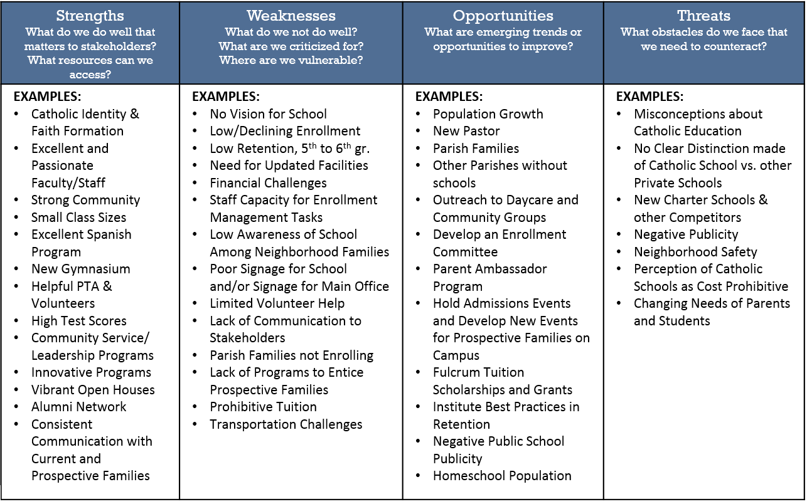

Do not distribute the sample SWOT Analysis above as it may risk dilution of committee discussion. Depending on the personality of a given enrollment committee, this exercise can be lively from the beginning or need some time to cultivate. If a group is slow to get going, or if the Enrollment Lead prefer, share copies of the blank SWOT Analysis Worksheet found in the Appendix. Give committee members time to consider the different qualities, opportunities, and strengths before re-engaging in conversation.

Make sure that the feedback is documented by the designated note taker. It is also important that any insights captured are developed beyond simple statements. For instance, if a member of the committee says that the teaching staff is excellent, ask them to give a specific example for saying that. Perhaps they have a very compelling story behind their reason to believe in the quality of the teaching at the school. Look to dig deeper into the statements of the Enrollment Committee, oftentimes there will be valuable insights to uncover with the power to inspire current parents and attract prospective parents.

The Enrollment Lead needs to ensure that each of the following areas are covered in this discussion by the committee:

* **Strengths:** What does the school do well that matters to the stakeholders of the school (e.g., students, parents, parishioners and the community)?
* **Weaknesses:** What are the areas with which the school either struggles or fails to deliver?
* **Opportunities:** Are there emerging trends or situations that could prove beneficial to either improve a weakness or further develop a strength?
* **Threats:** Are there emerging challenges that the school should be aware of in order to better position itself for the future?

**Additional Questions that can help facilitate a more robust conversation during the situation analysis of the school’s strengths, weaknesses opportunities, and threats:**

* What do parents and students most want from any school?
* What do parents and students most want from a Catholic school?
* What features does this Catholic school have to meet these needs?
* What are the specific reasons, rational and emotional, that a family chooses to attend this school? What do the school’s best advocates say about the school?
* What are the specific reasons, rational and emotional, that a family chooses NOT to attend? What do the school’s worst critics say about the school?
* Who are the school’s biggest competitors (list public, private and other Catholic schools?
* Why are families attracted to or dissuaded from sending children to competitor schools?

**Time for Perspective**

Before moving right into the process of identifying audiences for the school to persuade, it is important to recognize that the SWOT analysis has the potential to alter the morale of a committee in a negative manner. Even if there are far more strengths than weaknesses and the number of opportunities far outweighs the number of threats, human beings have a tendency to ruminate on negative concepts over positive. To combat this, it can be helpful for the Enrollment Lead to give the committee some perspective on what it will actually take for the school to be successful in reaching the Enrollment Target. This can be a good opportunity for the Enrollment Lead to introduce, or re-visit, both the school’s Snapshot and Enrollment Target Worksheet.

For example, assume that both the sample of the Enrollment Target Worksheet and the sample Snapshot (found on pages 17 and 18) are both for St. Catholic School. The current enrollment of St. Catholic School is 215 students and the school has a goal of increasing enrollment to 225 in the next year. While this is a total increase of 10 students from year to year, the actual number of new students needed to enroll is 38 (accounting for graduation and transfer students). This may seem like an even more daunting goal, but it is important to consider the size of the school aged population in the surrounding area.

The St. Catholic’s Snapshot lists 3,790 Catholic children between the ages of 5 and 14 in the school’s surrounding geography. Additionally, the parishes that surround and feed into St. Catholic are consistently baptizing over 110 children each year. If the school is to reach the goal of enrolling 38 additional students, they need only persuade about 1% of Catholic families in the total population. If the committee considers the total number of children, Catholic and non-Catholic, that number gets even smaller.

So it is possible that for every one “yes” there can be as many as ninety-nine “no” responses and the school would still be successful in reaching its goal. There is no need to worry about convincing each and every family or student to attend the Catholic school. In fact, much to the chagrin of Catholic school leadership, that is impossible. So it is very important to remain positive and to find creative ways when finding those families and students who are more likely to say “yes” and help the school grow.

**Identify Audiences to Persuade:**

The strengths and weaknesses identified in the first part of the robust conversation are indeed important to the parents of school-aged children. It is important to remember, however, that no one parent is exactly like another. For instance, recent national research by the Fordham Institute (2013) found that academic rigor and physical safety ***must be present*** for a parent to consider a school a viable option (so be sure to demonstrate the academic rigor and physical safety found at the school). Beyond safety and rigor, the study found that parents fall into six distinct segments based on their hopes for their child’s education:

***Strivers*** – (12% of K-12 parents) are primarily concerned with their child attending a top-tier university. These parents may find stories about alumni attending top-tier high schools or universities very intriguing.

***Jeffersonians***– (15% of K-12 parents) value a school that “emphasizes instruction in citizenship, democracy and leadership.” Examples of student leadership, character formation, and service projects could draw the attention of parents in this segment.

***Test-Score Hawks*** – (23% of K-12 parents) favor schools associated with high scores. If a school is able to promote high test scores, it is important to do so.

***Multiculturalists*** – (22% of K-12 parents) want their children to learn how to work with people from diverse backgrounds. In addition to ethnic diversity, examples of diversity in thought, style of learning, as well as the experiences of the student body and faculty are very effective.

***Expressionists*** – (15% of K-12 parents) want programs that emphasize music and art instruction. Many Catholic schools have found that programs in music and the arts are highly valued by parents and students.

***Pragmatists*** – (36% of K-12 parents) value a curriculum that offers vocational classes or job-related programs. If a school is able to promote a curriculum that can bolster a student’s resume at a young age, it is important to do so.

There are many different motivations for a parent to choose a school; this research lends insight in identifying some. The research from Fordham segments parents by their values, but those segments should not be considered exhaustive or mutually exclusive of one another. For instance, religious education as a preference was not included in this study, but Catholic school leaders know that the Catholic Identity of a school is a major factor for many parents. It may be worth noting that in 2012-2013 there were 974,000 Catholics in the Archdiocese of Seattle, of which roughly 125,000 were between the ages of 5 and 14. Additionally, there are more baptized Catholic children under the age of 5 (roughly 30,000) than in all of the Catholic elementary and high schools in the Archdiocese (22,000).

The Enrollment Lead can introduce the committee to some of the research above and (keeping only positive strengths and opportunities in mind) encourage another discussion about the different types of parents that already choose the school and those who might also be interested. Many of the members of the Enrollment Committee are likely parents, so they may begin to categorize themselves while the Enrollment Lead is introducing the different segments of parents in the study. If a conversation begins to pick-up naturally, the Enrollment Lead should ensure that the conversation focuses on parents that will (or already do) find that the school meets their needs.

**The following questions can help guide a discussion, narrow the focus of the committee on a target audience to persuade and begin to consider messages to that audience:**

* Do we have parents, like those listed in the Fordham study, at our Catholic school?
* Which particular segments do you notice? Can you give examples of why you consider parents to fit the mold described in the Fordham study?
* Are there parents at our Catholic school that are not found in the Fordham study? How are they different from the six segments in the study? Can you share an example that demonstrates some of their attitudes, beliefs, and values?
* What other types of needs and values do parents have that can be satisfied at our Catholic school?
* What programs does the school have (academic or co-curricular) that satisfy the needs of parents?
* What causes parents to worry when they think of their children’s education and future? Does our school provide a solution to those worries?
* Are the values and needs of families (current and prospective) changing from year to year? How? Are we positioned to accommodate changing values and needs? How?
* How old are children when parents begin to consider educational options for their children? Is there a process? If so, when does it begin and end?
* Where are the places that we can reach parents when they are considering educational options for their child? (e.g., daycares, websites, parent groups, kid camps, or other places parents can be reached)

During the discussion on target audience profiles, the designated note taker can record the different attributes of target audiences. After a robust conversation has taken place, the committee should begin to categorize the different attributes into “audience profiles.” An **audience profile** is a broadly generalized description of a parent, for instance the parents that are segmented in the Fordham study (e.g., Strivers and Jeffersonians).

This is an especially helpful exercise for the Enrollment Lead and Principal to do in advance of any Enrollment Committee meetings. Assuming that the Principal has been at the school (or in Catholic education) long enough to close their eyes and consider a hypothetical parent in their office that is interested in enrolling. The Enrollment Lead can ask the Principal the following:

* How old is this parent?
* Is a man or woman or both? Are their children with them in the Principal’s office?
* What is their income level, ethnicity, religion, and how far do they live from the school?
* Why are they interested in Catholic education and what, if any, are their concerns?
* What kind of INCORRECT perceptions do they have about Catholic school?
* What is unique to this parent and is it a consistent theme among a certain demographic in the school’s region?

The goal of these questions and conversation before and during an Enrollment Committee meeting is to create no more than 5 distinct, but fairly broad profiles of real types of parents that are (or should be) interested in the Catholic school.

Use the **Audience Profile Worksheet** to develop profiles inclusive of:

**Names:** Easy to remember and descriptive, such as “Parish Families.”

**Demographics:** Include age ranges, income levels, languages, ethnicities, and religions.

**Values:** Examples include faith formation, after school care, and language instruction.

**Perceptions:** Use stereotypes and consider what committee members have heard actual parents say, such as “Catholic school would be ideal, but too expensive.”

**Behaviors:** List what is already known to be unique about an audience. If possible, recall previous successful recruitment efforts and share any key learnings.

**Location:** Where do they live and work? What are the best ways to reach them and when are the right times?

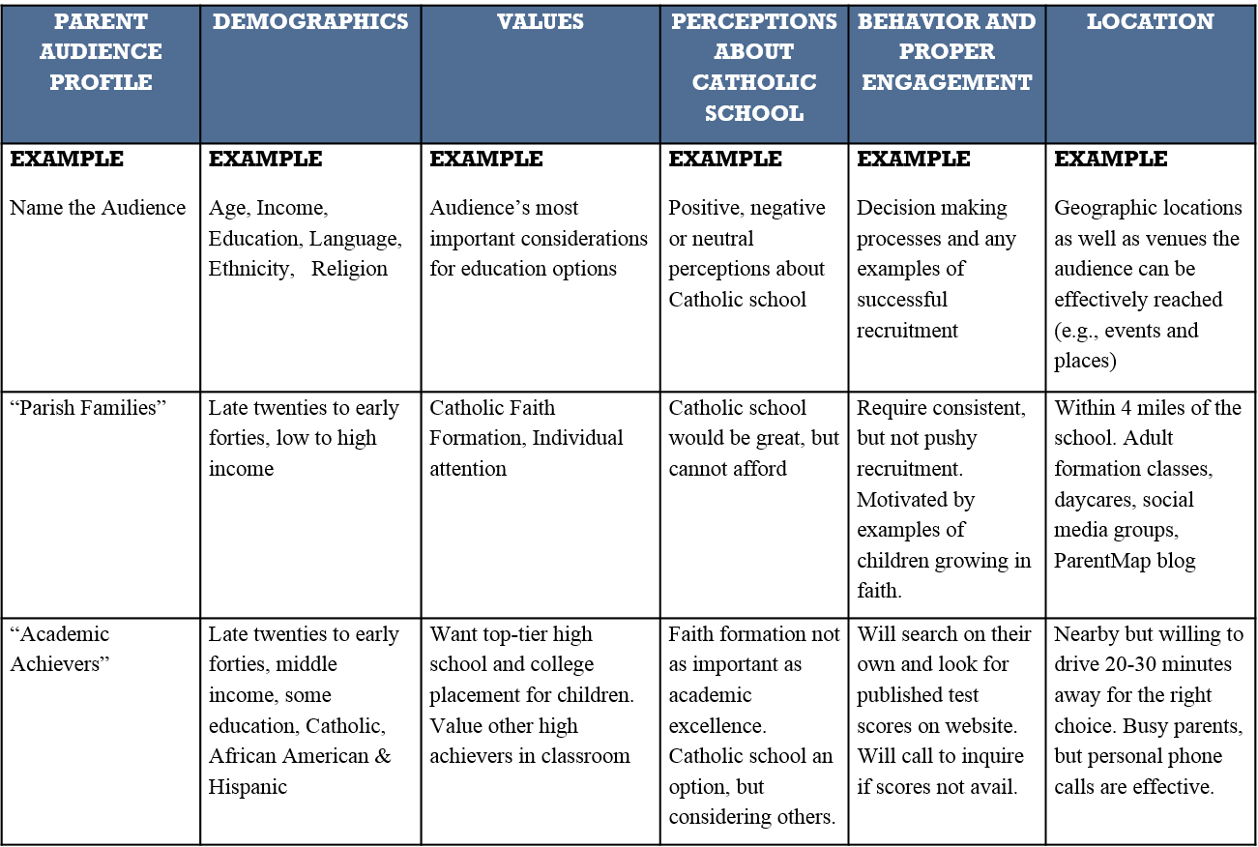

*A blank Audience Profile Worksheet is located in the Appendix.*

The Enrollment Lead should limit conversation to parent profiles representing real populations that would be likely to enroll in the Catholic school when properly engaged. If conversation begins to dwell on reasons that families have not enrolled, steer back to real examples of families that are happy members of the school community.

**Fundamental questions to keep conversations on track and to gain deeper insights, include:**

* Is a profile descriptive of a real audience’s values, perceptions, and behaviors?
* Is an audience profile descriptive of parent communities in the surrounding geography?
* Does the school already meet the needs of the profile? If so, does this profile perceive that the school meets their needs? Why or why not?
* Does the school actively recruit and enroll families in this profile? If not, should they? If so, how can it be done more effectively?
* Is the school effectively highlighting the strengths in these profiles to all parents? Are there segments of parents that the school does a great job connecting with? Which segments can be reached more effectively?

**Communication Planning**

Before developing a new communication plan, the Enrollment Lead should map the school’s existing communication methods and messages with the following **Communication Map Worksheet**. Consider all types of communication with current families, prospective families, the parish community, and the broader community. The goal of this activity is to ensure that the Enrollment Committee considers the many different opportunities to intentionally communicate the school in a positive manner.

It will be helpful for the Enrollment Lead and Principal to complete the Communication Map Worksheet in advance of discussing with the Enrollment Committee.

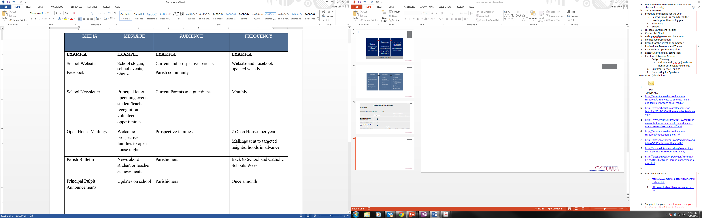

The following questions lead to a discussion uncovering opportunities to make an impression:

* What are the different ways that the school communicates to current parents and the broader community? (Even consider: students going door to door for fundraising, school signage, and outward appearance examples of the school making an impression in the community)
* What are the messages? Are they consistent? What can be improved?
* How can teachers, students, staff, parents, and the parish better promote the school?
* What are the best methods to highlight the school’s success stories?
* Does the school’s website communicate all that is good about the school?
* What are the most effective ways to reach the parish community?

**Value Propositions**

The following example illustrates a method of identifying one of many possible value propositions for the school. The “key value statement” given in this example speaks to the academic excellence of the school (an important consideration for many parents), the statement is supported by proof points demonstrating reasons to believe the original statement is true. Potential communication methods outline different mechanisms to highlight the value proposition and attract an audience.

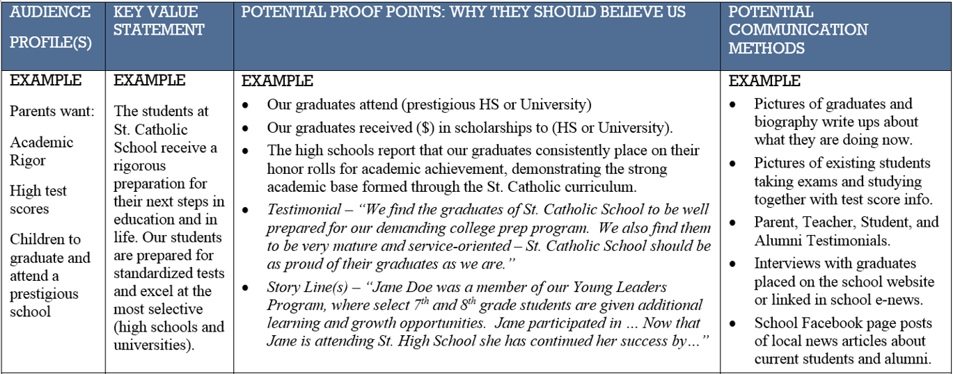

*Additional Value Proposition Worksheets are available in the Appendix and can be distributed to the members of the Enrollment Committee for work during or in between meetings.*

**IMPORTANT: Communicate a Responsible Tuition Strategy:**

The topic of money and the cost of Catholic education is a source of anxiety for many families, even when a school has a real and perceived benefit. It is important for the Enrollment Lead and Principal to be mindful in communicating opportunities for scholarships and financial assistance.

If a school offers financial assistance to families in need, it is important that they do so in a manner that respects the stated tuition. Rumors or statements among the parent community to the effect that “no one pays stated tuition” will place the school’s long-term financial stability in jeopardy and reinforce a belief that Catholic education is not worth the cost. It is important to use appropriate language in the description of any financial assistance. and to keep tuition conversations confidential between a family and school administration.

**COMMITTEE FOCUS: RECRUITMENT**

Recruitment efforts at Catholic schools are a strategic process of **finding, attracting, and ultimately enrolling new families into the school community**. After completion of the work outlined in the marketing section much of the necessary strategic planning to find and attract new families has been addressed. For example:

**Finding New Families:**

* + - Specific and achievable enrollment target has been set.
    - Physical locations and opportunities to engage new families are determined.
    - Parent audience profiles of those more likely to enroll have been created.

**Attracting New Families:**

* + - Audit of current communication methods undertaken.
    - Desirable, realistic, and actionable vision for future of the school is developed and the process to actively and openly share that vision with the school community has begun.
    - School value propositions created aligned to the specific parent audience profiles.
    - Communication schedule including medium, message, and audience is planned.

The Enrollment Committee work to this point has created a necessary foundation for school communities seeking to improve enrollment. The Enrollment Lead and Principal are encouraged to take time and celebrate the accomplishment including giving appropriate thanks to the committee for the good work to this point.

**Moving Forward**

The next phase of Enrollment Committee work will sharpen the focus of the school to the actual enrollment of new families.

After completing this section, the Enrollment Committee develop a recruitment strategy that:

* Supports the vision and value propositions of the school.
* Ensures a welcoming and accessible environment for all families.
* Employs a Parent Ambassador Program to grow staff capacity and enrollment.
* Creates multiple opportunities for potential families to visit campus and enroll.
* Focuses recruitment efforts on the entry points of the school.

(e.g., Pre-K, K, 6th and 9th Grades)

* Measures progress to enrollment targets.
* Keeps track and provides personalized follow up with families showing interest.

**RECRUITMENT PRINCIPLES**

**Entry Points**

The vast majority of parents interested in new education options are looking at the entry points of schools, for this reason recruitment efforts should be focused on. For elementary schools this means filling Pre-K and Kindergarten classes as the first priority, for a high school this means 9th grade recruitment. Transfer students can certainly be helpful for enrollment, but the number and frequency of transfer students pales in comparison to the school’s entry points.

**A Welcoming and Accessible Environment**

The entire Catholic school community will play a part in a prospective family’s decision to enroll. Both positive and negative first impressions can make or break a decision. Research suggests that it can take as many as twelve positive impressions to make up for just one negative impression, so it is important to maintain a positive culture at the school.

**Personalize the Visitor Experience and Follow Up**

It is important to personalize the experience of a prospective family. Many schools have found it helpful to give each visitor to the school a name tag, so that each member of the school community can remember and use their name during the course of a visit. When the school follows up with a family, phone calls and written notes convey that individualized attention will also be shown in the education of a family’s child.

**Promote the Vision and Value Propositions**

Each member of the school staff, Enrollment Committee, and Parent Ambassador Program should know and live the vision for the school. Interactions with prospective families represent an important opportunity to spread that vision and demonstrate it through action. In conversations, uncover the needs of the family and relate their needs back to appropriate value propositions of the school.

**Tuition Should Never Start or End a Conversation**

Depending on the tuition structure and financial aid capabilities of the school, develop a strategy to communicate tuition publicly and ensure individual arrangements remain confidential. Posting the school’s tuition on the website will deter families from the start, instead refer to the percentage of families that receive financial support and information about the availability of scholarships and Fulcrum assistance.

**PARENT AMBASSADOR PROGRAM**

***Introduction: Happy Parents are the #1 Recruiters for Catholic Schools.***

Parent Ambassador Programs have helped Catholic schools across the country to improve their enrollment through an organized word of mouth campaign. Word of mouth promotion is often referred to as the “least expensive and most effective form of advertisement.” This maxim holds true today more than ever as hundreds of millions of customers constantly search online for product, restaurant, movie, and many types of reviews before spending their valuable dollars.

In a similar manner, parents are constantly seeking and receiving input from one another on nearly every matter of raising children (education choices are an especially popular topic among parents of children approaching Pre-K, K, 6th, and 9th grade). Both personal testimonials and second hand information have enormous power to influence decisions, so each interaction with parents (current or prospective) is an opportunity to positively promote the school.

It comes as no surprise when a school with happy parents has healthy enrollment, but there are also schools that struggle with enrollment and have plenty of happy parents. Factors that may include the culture and physical location of the school can enhance the visibility of a school or work against it. Many people can remember a favorite restaurant that was a “hidden gem,” over time a hidden gem is either discovered by more patrons or closed for lack of business. Catholic schools cannot be “hidden gems,” the very nature of Catholic schools requires them to be pillars of their local community.

Happy parents must understand the importance of their role in the health of the school. They should understand the vision leadership has for the future, what it will take for the school to reach that vision, and what the end result will look like. When parents believe in the vision for a school they are able to help make it a reality.

Combined with the previous work by the Enrollment Committee, this Parent Ambassador Program Guide will assist school leadership to:

• Advance leadership’s vision for the school

• Organize, launch, and manage an effective word of mouth campaign

• Recruit, motivate, and train effective Parent Ambassadors

• Enroll more kids in great Catholic schools

**Guiding Concepts for the Parent Ambassador Program**

**Connect the Vision for School’s Future to the Annual Enrollment Target:**

* Continually share the vision of the school’s future with parents and the community.
* Communicate annual the year’s Enrollment Target as step towards that vision.
* Focus on 1-3 main “Areas of Focus” for Parent Ambassadors to achieve Enrollment Target.

**Get the Right People and Make Personal Invitations:**

* Always make personal invitations, via phone or in person, to parents who represent the school best. Outgoing, positive, well-spoken, and faith filled people make great ambassadors.
* Everyone has something to offer, but be very selective and clear when assigning leadership roles. Intentionally match skills with responsibilities and find ways for all to help.

**Congruency and Collaboration:**

* Design a program that will fit the culture and vision of the school.
* When possible, work in concert with existing organizations like Parent Clubs.
* Reach out to other schools to gain insights on creative strategies.

**Service Hours:**

* Encourage parents to view initiatives as opportunities to fulfill service hour requirements.
* Hold parents accountable to meet service hours, promote the many opportunities.

**Drop-In Volunteers:**

* Develop a list of tasks for volunteers that drop-in unexpectedly during a school day.
* Reference the Area of Focus: Office Support, School Help, & Facilities section for examples.

**The Parent Ambassador Guide is organized into four main parts:**

1. **IDENTIFY AREAS OF FOCUS (page 35)**

Determine 1-3 Areas of Focus aligned to the enrollment target.

1. **PLAN PROGRAM KICKOFF (page 42)**

A directed and energetic kickoff event will tone and create momentum.

1. **PERSONALLY INVITE ATTENDEES (page 43)**

Get the right people in the program by personal outreach.

1. **TRACK RESULTS AND CELEBRATE WINS (page 44)**

Track progress to goals, create a culture of success, and grow each year.

**1. IDENTIFY AREAS OF FOCUS**

**The Principal and Enrollment Lead should review this section together before introduction to the broader committee.** School leadership should consider the vision for the school, the Enrollment Target for the year, and the culture of the school community.

Effective Parent Ambassador Programs are limited in their scope. **It is highly advised that school leadership limit the focus of the Parent Ambassador Program to 1-3 Areas of Focus per year.**

It is important that the committee determine Areas of Focus for the school’s Parent Ambassador Program. Each of the following areas is discussed in greater detail in this section:

* Admissions Events and Foot Traffic (page 36)
* Parish Presence and Outreach (page 37)
* Multi-Cultural Outreach (page 38)
* Office Support, School Help, & Facilities (page 39)
* Religious Education Outreach (page 40)
* Mentors for New Families (page 41)

A discussion led by the Enrollment Lead, should answer the following questions:

* Does this Area of Focus fit into the vision that leadership has for the school?
* Will this Area of Focus help us toward our Enrollment Target?
* Will parents bring an authentic positive energy to this Area of Focus?
* Which activities would be most helpful?
* Who are the specific parents that will make this successful?
* How can this Area of Focus be adapted to our school culture to make it more exciting?

**Areas of Focus**

**ADMISSIONS EVENTS AND FOOT TRAFFIC**

Principals generally have a high degree of confidence in enrolling prospective families once those families visit campus. Increasing the amount of regular foot traffic by prospective families and ensuring high quality admissions events each year is of utmost importance for enrollment health.

Activities for Admissions Events and Foot Traffic:

* Develop school marketing packets to give to prospective families during visits and tours. Include materials that promote the value propositions of the school and develop positive expectations of membership in the school community.
* Develop a roster of parent volunteers to give tours to prospective families. Keep track of visiting families and follow up with personal phone calls.
* Build phone and email lists of current parents in each grade or classroom that could act as good representatives to prospective parents. This list can be handed out to families considering enrollment, leaving a good impression about the openness of the school community.
* Help plan, promote, and staff Admissions Events. When an admissions event is around the corner, enlist parents in promotion efforts via email, phone calls, social media, and web.
* Develop new events to draw people to the school in creative ways (e.g., breakfast with Santa, Easter Egg Hunt, Family Fun Night, Literacy Night, Movie Night, Bingo, and Game Night). Seek partnerships with existing parent organizations to assist in the creating, promoting, and staffing.
* Develop a list of families with children between the ages of 1-12 who might be interested in the school. Determine an appropriate call to action and organize a phone-a-thon or social media campaign to invite new families to the school.
* Consider connections to community groups or organizations that may be able to assist in recruiting. Real estate brokers, for instance, may know when new families move into town.
* Share good news among current parents and tell them to notify the principal if they learn information that is important to know.
* Reach out and distribute school marketing pieces to local daycares, pre-k centers, and other places that parents and children gather. Act as a point of contact for other parents who may wish to ask more questions about the school. Consider other outreach to the local community, including businesses, with a call to action to attend an event.
* Promote the school to other parents whose children participate in extracurricular activities with their children.

**Areas of Focus**

**PARISH PRESENCE & OUTREACH TO PARISHES WITHOUT SCHOOLS\*\***

Parishioners are an important audience for enrollment and fundraising efforts, they should hear about the positive things happening in the school. Parent Ambassadors can be a consistent source of help in this area, especially when they are active members of the parish.

Activities for Parish Presence and Outreach:

* Schedule informal meetings with the Pastor and members of the Parent Ambassador team (e.g., take the Pastor to breakfast). Look for ways for Parent Ambassadors to help the parish and develop more positive interactions with the Pastor. Involve key parish staff.
* Develop procedure for parish outreach. Learn the process and deadlines to schedule Mass announcements, submit bulletin entries, and host an information table. Consider other religious services in your region.
* Determine available opportunities inside the parish to reach out to prospective families (e.g., baptism lists, new parishioners, and parish groups).
* Create and execute a calendar of speaking engagements at the parish and other parishes in the area. Host events for parish families.
* Create school flyers and distribute after Mass. Include a call to action like an open house invite, special event or school tour. Have students in uniform hand out parish bulletins.
* List the closest Catholic and non-Catholic churches without schools. Determine if any current parents are members of these churches and if they are willing to help create a new connection. Enlist the help of the school’s Pastor, when appropriate, to assist with this outreach.
* Schedule time for the Principal and a Parent Ambassador to meet with pastors at local parishes without schools. It is especially helpful if your pastor is willing to help in this area.

***\*\*Be sure to: Ask permission first and remain respectful of the Parish and the Pastor.***

**Areas of Focus**

**MULTI-CULTURAL OUTREACH**

Depending on the demographic makeup of the school’s surrounding community (or certain features of parish life such as Mass in other languages), a real opportunity for better inclusion of multi-cultural communities may exist. Despite Catholic education’s long and unmatched track record of success in educating poor minority students, some communities harbor a belief that Catholic schools are highly exclusive. Parent Ambassadors can work against these dangerous misconceptions.

Activities for Multi-Cultural Outreach:

* When appropriate, find parents who can act as translators for families with limited English during tours and Open Houses. Offer times during school hours when parents or volunteers can answer and make phone calls in a given language. Promote this offering in school marketing materials.
* Speak at non-English Masses in the appropriate language. Invite communities to consider and tour the school.
* Assess whether the school and staff has experience with cultural diversity and determine if there are areas to improve a spirit of welcomed inclusiveness.
* Host listening sessions for multi-cultural communities that participate in the parish, but choose not to enroll in school (common among Hispanic families). Seek to understand reasons for disparities and create a plan with a community to create a more inclusive environment.
* Host events for multi-cultural communities on campus.
* For parents interested in enrolling, but hesitant, allow a family to try the school for a day or week.

**Areas of Focus**

**OFFICE SUPPORT, SCHOOL HELP, & FACILITIES**

Any type of volunteer assistance can make a big difference for the school. For some parents, acting as a vocal ambassador may be outside their comfort zone or skill set. Find ways to make sure parents feel welcomed to volunteer in many different ways.

Activities for Office Support:

* Anticipate parent volunteers coming to school unexpectedly and looking to satisfy service hours. Always have a number of options that would be helpful and lessen the load of the paid staff. Include a strategy for parents who may not be able to make it into the school, but can accomplish helpful tasks from home.
* Seek out technology assistance such as website help, marketing materials design, and production from parents with the appropriate skills, talent, and resources.
* Keep track of parents visiting the school for tours and admissions events. Enter the information into a database and create call lists for follow up.
* Organize and execute mailings to current and prospective families. Ensure a call to action, such as an invitation to an admissions event.
* Identify and complete grant applications to secure new programs or financing for the school.
* Answer phone calls from prospective families, give tours on campus, and meet privately with prospective families. Provide a level of welcoming and accessibility that is consistent with the culture and vision of the school.
* Obtain the school’s press release template and send weekly school news and high-resolution photos to the local media sources about school activities.

**Areas of Focus**

**RELIGIOUS EDUCATION OUTREACH**

Many parishes throughout the Archdiocese have healthy enrollment levels in religious education programs. In some cases, parish families with children in religious education programs have never been contacted by Catholic schools.

Religious Education Outreach Activities:

* Reach out to the Pastor, in coordination with Parish Presence team, for approval. Set up a time to connect with the Religious Education Director.
* Learn the registration process for religious education students and the calendar of the program including the times and places that they meet. Determine a good time to contact families and invite them to school events. Find out if there are any opportunities for religious education families to participate in school events. If none exist, create some?
* List neighboring parishes with religious education programs to contact and write testimonial letters to families in the programs.

**Areas of Focus**

**NEW FAMILY MENTORS**

Parent Ambassadors can assist in enrollment management efforts beyond recruitment and can play a critical role in retention. Many current parents serve as mentors to new families, especially if the Parent Ambassador played a large role in the new family’s decision to enroll.

New Family Mentor Activities:

* Reach out to new families before the year starts and answer potential questions
* Host a new family welcome event at the school
* Meet in advance of the school year for children to meet and parents to get acquainted
* Serve as communication liaison between school office and families
* Function as “parking lot” monitors
* Act as “Room Parents”

**2. PLAN PROGRAM KICKOFF**

The work of the committee to this point has determined focus for the Parent Ambassador Program that will help to improve enrollment at the school. Now it is important to plan an exciting kickoff event that will generate a level of excitement and momentum necessary for successful program.

**Sample Agenda- (meeting should last no more than 2 hours)**

1. Introduction and Welcome
2. The School Vision and Enrollment Targets
3. Overview of the Parent Ambassador Program
4. Areas of Focus
5. Open Forum
6. Next Steps and Meeting Date

Goals for the Parent Ambassador Kickoff:

* Positive and exciting atmosphere
* Share the vision for the program and the school
* Demonstrate proper communication of school value propositions
* Provide overview of the program:
  + Power of Word of Mouth Promotion
  + This Year’s Specific Enrollment Target and Areas of Focus
  + The Community Benefit of Healthy Enrollment
  + Needed Time Commitments (As little as 3 hours per month make a difference)
  + Incentives for Ambassadors (if applicable)
  + Communicate Plan to Share Progress to Enrollment Target
* Open Forum: Ideas and suggestions from current parents
* Next meeting date set

**3. INVITE ATTENDEES**

In order to ensure a high turnout, the Enrollment Committee can assist in planning and promoting the event. Sample call scripts are located in the Appendix.

**Parents’ first impressions about the Parent Ambassador Program are important.** Share the excitement the Enrollment Committee has for the organization and develop some interest in the kickoff event. Consider serving food and be sure to host the event on a night that parents will attend. Try to avoid scheduling an event that coincides with other major dates to ensure the maximum turnout.

**Identify the parents that the program cannot do without and make phone calls to personally invite them.** This is the most effective means of recruiting ambassadors and an easy way to ensure strong participation and leadership. Even if some may be unable to attend or participate, the act of personal outreach will communicate the value school leadership places in their community involvement. This type of outreach may reap unforeseen benefits in the future. It is recommended that the Enrollment Lead consult *the* ***personal call script sample*** *in the Appendix as a guide, but it is recommended that callers speak in their own words as much as possible.*

**Plan the event for a date, time and location that will ensure maximum turnout, especially among parents who received a personal invitation.**

**Look to identify key traits in potential Parent Ambassadors that meet the needs of the Areas of Focus.** Parents with helpful skills or traits, ethnically diverse parents, parents with children in a range of different grade levels, parishioners, and other local organizations.

**Send an email, a note to take home and a notice to the entire school to inform parents about the start of the Parent Ambassador Program.** Be sure to invite anyone else that may be interested in improving enrollment at the school. A general invitation to all keeps parents from feeling excluded and may bring people and resources to light that had not been considered.

**4. TRACK RESULTS AND CELEBRATE WINS**

***REMEMBER: Happy Parents are the #1 Recruiters for Catholic Schools.***

Celebrate every success as it happens to build a sense of accomplishment among Parent Ambassadors. The morale of the group will be very important, taking time to recognize the helpfulness of a Parent Ambassador by enrolling a new family or staffing an event helps develop positive momentum. At the end of the year, regardless if the school reaches the Enrollment Target, keeping a positive and appreciative tone for the hard work of all volunteers will make an enormous difference.

Parent Ambassador Programs should not have to be re-invented each year. Consider the following ways to ensure the long-term sustainability of the group:

* An end of the year parent appreciation event; either a lunch, dinner or party.
* Include successes of the program in the school newsletter and parish bulletin to enhance community activity and generate interest among other parents and volunteers.
* “Promote” your top ambassadors at the end of the school year to lead specific Areas of Focus for the next year.
* Give Parent Ambassadors clothing with school logos, make them identifiable at school events and visible ambassadors outside of the school environment.
* Celebrate a Mass specifically for the Parent Ambassador Program.

**ADMISSIONS EVENTS GUIDE**

**The Enrollment Lead, under the supervision of the Principal, is responsible for planning, organizing and executing on-campus events for prospective parents.** When a prospective family sets foot on campus, the odds of enrollment are much higher. Campus visits, whether planned or unplanned, are a tremendous opportunity for the school to make a positive impression and for families to develop positive expectations of membership in the school community.

This section is designed to help the Enrollment Lead plan events well in advance and show the school in its best light every day.

To prepare the school for enrollment success during an admission event, follow these four steps:

1. **PREPARE**
2. **INVITE**
3. **HOST**
4. **FOLLOW-UP**

**1. GUIDING PRINCIPLES TO PREPARE FOR ADMISSIONS EVENTS**

**Everything is an Admissions Event:** 7 days a week, 24 hours a day, and 365 days a year the school can make positive or negative impressions. Prospective families are judging the building, the website, the person answering the phone, the answering machine, current families, and what other people are saying. Ensure the school is shown in the best light possible at all times.

**The End Goal is Enrollment:** Admissions Events always have the end result of enrollment in mind. Collect contact information of all visiting families. Be prepared with appropriate paperwork if a family is ready to enroll on the spot.

**One Open House is NOT Enough:** Plan to host multiple Open Houses each year. Double check dates and times for any possible logistical issues – i.e. parish events, parking lot issues and other events that influence traffic.

**Activate the Community:** Students should know to be respectful and welcoming towards those touring the school. Use Parent Ambassadors to give tours and recruit. An active and engaged community is a very attractive feature of a Catholic school.

**Be Prepared to Answer Questions:** A list of Frequently Asked Questions by potential families is found in the Appendix. Anticipate answers to these questions and provide follow up. Distribute the list of questions and answers to visiting families and those acting as tour guides and ambassadors.

**Marketing Materials:** Especially for an Open House, have marketing materials ready to distribute families touring the school. Always keep extra copies on hand for unexpected visits by prospective families. Include only information that is going to address the family’s needs and move them forward in the enrollment process. Here are some examples of information that parents might find helpful in a packet:

* Statistics on Faculty, Staff and Specialists
* Curriculum and Academic Programs
* Technology Offerings
* Co-Curricular Activities
* Volunteer and Service engagements
* Unique Community Traits & Parish Connections
* Multi-Lingual Materials
* Current Parents in Every Grade Willing to Talk to Prospective Parents
* Answers to Frequently Asked Questions

**Staff & Faculty:** Ensure a roster of current staff in attendance at Admissions Events. When a family comes in for a visit, front desk staff should make an effort to introduce that family to the appropriate teaching staff (depending on the age of family’s children).

**2. INVITING PROSPECTIVE FAMILIES TO ADMISSIONS EVENTS**

Invitations to the campus for any type of admissions event are crucial to the success of recruitment efforts. This includes personal invitations to potential families, general advertisement of events, and working with Parent Ambassadors (and other volunteers, staff, and parish leaders) to promote the school on an ongoing basis.

**Current Community:** Send an invitation home to current families to inform them of ongoing admissions efforts. Offer incentives or engage this community in friendly competition to find new families. Identify parents that may be particularly helpful in promoting the school and bring them into the Parent Ambassador Program at the school. Include information in the Parish bulletin (as well as surrounding parishes without schools) about open houses, enrollment processes and opportunities for financial assistance.

**Identified Prospects:** If a family is new to the parish community, or has shown interest at one time or another, personally invite them to tour the school or attend an admissions event. A phone call from the Principal or an engaged parent volunteer can make an important impression.

**General Advertisement:** When advertising for a specific admissions event (as opposed to general tours), advertise early and as inexpensively as possible (for instance, online, newsletters, and email). Engage parent and parish communities in the process.

**3. HOSTING PROSPECTIVE FAMILIES AT ADMISSIONS EVENTS**

Visiting families bring a mixture of feelings and anxieties to their visit. The school should be prepared to make them feel comfortable in a positive and welcoming atmosphere. It may be helpful to consider a prospective family’s experience from the moment they leave their home until they return home.

* Ensure that appropriate signage informs first time visitors where to park and how to find the main office. If a school doesn’t have appropriate signage, have parking lot Parent Ambassadors help assist prospective families. This is not only good hospitality, but also a safety precaution.
* Staff and volunteers in the main office should understand basic protocol to smile and welcome people to the school. First impressions are important, so properly training and reminding staff to be welcoming to prospective families is critical.
* Always collect data and give visitors a name badge so that tour guides can remember the names of the family members. This will also be helpful during follow up.
* Ask questions of the family on their visit, remain attentive to their experience:
  + Do they have any questions?
  + How did they hear about the school?
  + Are they new to the area?
  + What are they looking for as they consider education options?
  + During their visit, try to visually demonstrate that the school satisfies any concerns.
* Some families may need language translation. If the office has a bi-lingual staff member, try to utilize their skills. Otherwise, try to find a current parent that can act as a translator during the recruitment process.
* Give a guided tour of the school and show off the most attractive features of the school. Visit classrooms, share testimonials of current parents, and address any questions.
* Conclude the tour in a private office to debrief, share the schools packet of marketing materials and inform of next steps to enroll.
* If the school has capacity, ask them if they’d like to enroll now.
* Never let the conversation end with tuition. Be prepared to share information about tuition and financial aid in a confidential environment.

**Answering Phone Calls:**

Ensure that each phone call is answered promptly by a friendly voice capable of answering questions (or finding someone else who can) and record contact information for follow up. When available, the Principal should speak to the prospective family to help move them to enrollment.

**4. FOLLOW-UP WITH PROSPECTIVE FAMILIES**

Always working to enroll means ensuring proper follow up after an event. Without follow up, a perfectly run event or interaction can become a total waste of time. Parents have many demands and multiple options to educate their children, here are some ways to ensure proper follow up.

**Principal:** Use information provided from sign-in sheets to write handwritten notes to each of the families. Email is also an option, but only if an email includes a personal recollection of a family’s visit or follow up to a family’s question. An email that reads like a “blast email” is impersonal and leaves a bad impression. Demonstrate individual attention to the family and perhaps include an invitation to another upcoming school event.

**Staff:** After collecting the data from the sign-in sheets at an admissions event. Store the data in a centralized location and track future interactions with individual families to ensure follow up that is purposeful and not redundant. If someone indicated that they were likely to attend and didn’t, follow up to see if they would like to schedule a private tour.

**Parent Volunteers:** Follow up calls to prospective parents who have children at their grade level or near their grade level. Parent volunteers can ask for honest feedback about the event and also move a family forward to enrollment.

**Students:** Students can also play a part in follow up to prospective families. Some schools have found it very effective for current students to write letters to families explaining why they are happy at the school.

Every kind of admissions event includes an opportunity for reflection:

* What was positive and what can improve?
* How many families enrolled?
* Solicit feedback from volunteers and staff.
* Ask touring families for feedback, including a decision to not enroll.
* Keep track of the efforts to drive attendance to Open Houses:
  + Determine if expected attendance matched actual attendance
  + What factors might have contributed to strong or weak attendance?

**COMMITTEE FOCUS: RETENTION**

The next phase of committee work primarily focuses on the development of a consistent process to re-enroll current families. A core component of retention is the regular communication with current families that reinforces the school’s value propositions. Just because a family decided to enroll at one time in the past, does not mean they should never be reminded that the school remains a worthwhile investment. When parents re-enroll their children year to year, it is an indicator of a positive relationship and oftentimes these families are effective advocates for the school.

Regardless the enrollment target, the vast majority of the students needed to reach that target are already sitting in the classroom. When poor retention rates exist, a much greater pressure is placed on the need to enroll new families.

Retention strategies the Enrollment Committee should consider include:

* Using Parent Ambassadors to enhance current family attention to re-registration
* Encouraging and incentivizing families to re-register before the end of school year
* Enlisting students and faculty in retention strategy, (e.g., classroom competitions to see who re-registers first or letters sent home to parents from teachers of the next grade)
* Sending a Letter of Intent home in advance of re-registration activities
* Maintaining a consistent communication with current families
* Kickoff of re-registration activities during Catholic Schools Week or at a State of School Address

To adequately address retention at a school, the Enrollment Committee should develop a retention program that:

* Projects a gracious attitude to current families and is consistent with the vision and value propositions of the school.
* Provides ongoing communication with current families about the value propositions and vision for the school.
* Gives parents multiple opportunities and reminders to re-register for the next year.
* Protects the welcoming and accessible environment the school provides.
* Keeps track on a yearly basis of the percentage of families that stay at the school.
* Employs methods to track the satisfaction of current parents.
* Anticipates potential objections of current families to re-registration.

The workbook Appendix provides templates that demonstrate many of these suggestions, the Enrollment Lead is responsible to develop a re-registration program that will work best for their school.

**STATE OF THE SCHOOL EVENT**

Working together with the Principal and the School Commission, the Enrollment Committee can plan and organize a State of the School event to:

* Encourage existing families to re-register for the upcoming year
* Deliver updates regarding the overall health of the school, including successes and challenges as well as goals regarding academic, spiritual, and financial aspects.
* Engage families in a deeper understanding of the school to increase support
* Encourage existing families to invite other families who might be interested in learning more

The Enrollment Committee can be particularly helpful in promoting the event to drive attendance. Some strategies to drive attendance include:

* Multiple letters, emails, and text messages to families to inform and remind of the event.
* Promotion of the event on the school’s website and placement on the school calendar at the beginning of the year.
* Financial incentives for those who attend, such as a reduced registration fee.
* Invite parishioners, produce bulletin inserts, and distribute flyers in the neighborhood to create broader awareness of the event.

**Sample State of the School Agenda**

1. School Commission Chair welcomes audience and states goals for the evening
2. Opening Prayer – School Pastor
3. Brief Presentation from Pastor reminding families to support the parish and promotion of different pastoral and adult education opportunities
4. Student Presentation
   * Stories: Video, PowerPoint or Presentation
   * HS/College Acceptance and Matriculation Data
5. Principal Address:
   * State of the School
   * Goals for the Year
6. PAA/Bookkeeper Presentation RE: Budget and Tuition
7. Provide Parent Feedback Opportunities (Either Q&A or suggestion box)
8. Closing Prayer and Something for Parents to Take Home
9. Adjourn

**Follow Up**

After the meeting it will be important to send out a letter to all families, including any new families whose name and contact information was collected, to summarize the meeting.