Creating a Free/Reduced Lunch & Spoken Language Report in FACTS

To create a free/reduced lunch & spoken word report

- Login to FACTS Grant and Aid

- Go to “Reports” tab

- Select Term: 2018- 2019

- Click “Create a new report”

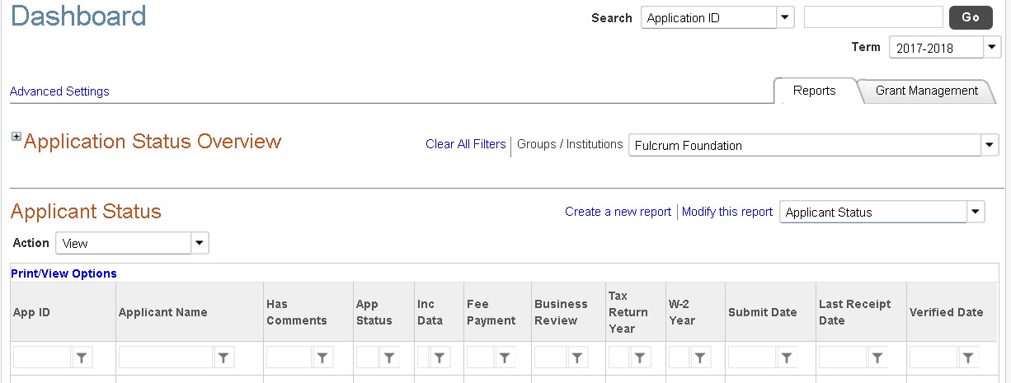
2
3
1

- Select Student report
NOTE: Spoken language information is only available in student reports

- Find and add the fields below to the report. Searching for fields in the search bar is much faster and easier than scrolling through the 200+ available fields.
  - App ID
  - Applicant Address 1
  - Applicant Address 2
  - Applicant City
  - Applicant Postal Code
  - Federal Poverty Guideline
  - Federal Free Lunch Guideline
  - Federal Free Lunch Program Qualified
  - Federal Reduced Lunch Guideline
  - Federal Reduced Lunch Program Qualified
  - Child Learned to Speak Another Language {Custom}
  - Most often Speaks a Language Other than English {Custom}

- Name the report, click “Save” or “Update” and return to Dashboard

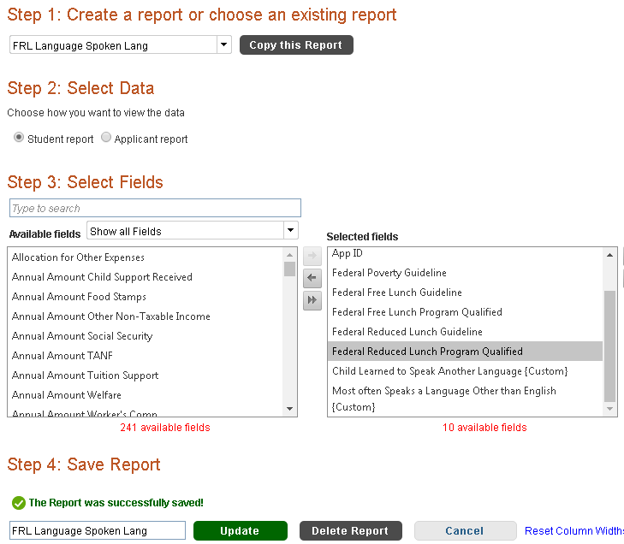
65
55
4

- Click “Print/View Options” and select “Export Data,” then “To Excel (unformatted).” The file will export as a .csv file which can be saved as an Excel Workbook.
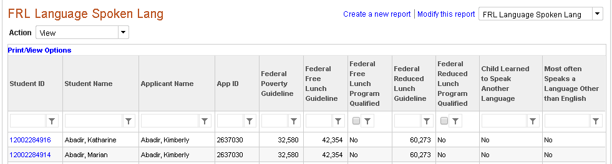
85

