Post MAP Testing Data Wall Protocol: Examining School Data
Step 1.  PRINT/ ACCESS REPORT | Login to the NWEA reports site: https://sso.mapnwea.org/auth/login. Download and print the NWEA Achievement Status and Growth Projection Report for your students (View Reports → Map Growth Reports → Projection or Summary). Make sure you click Fall 2017-2018 for term rostered and term tested. Choose the growth comparison period that corresponds to the next testing window at your school. If you have a small class/ grade, you will need to click the “small group display” button before generating the report. For more detailed instructions on how to access this report, click here.  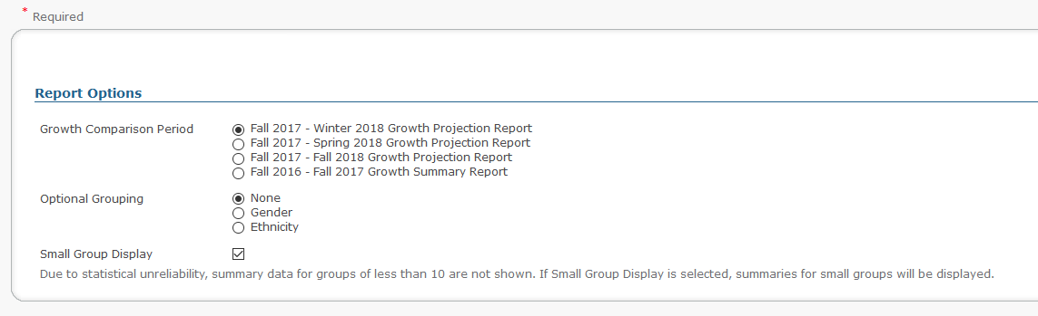
Step 2.  IDENTIFY STATUS NORM | Look at the NWEA 2015 Normative Data here: https://www.nwea.org/content/uploads/2015/08/2015-MAP-Normative-Data-NOV15.pdf. This data represents normative RIT scales and measured growth from a large student sample study in 2015. The Status Norm is the RIT score indicated under the “Mean” column. The column labeled SD means Standard Deviation. This represents the variability of scores within a group. A larger standard deviation reflects a wider range of scores. Identify the status norm for the grade level, subject area, and testing period you are reviewing. For example, Grade 2, Begin-Year (fall), Reading.
Step 3.  CREATE DATA CARDS | Create a data card for each student. Each card should look like the sample below. If you don’t have last spring’s RIT score, leave S17 blank. When recording student’s RIT scores, use the bolded RIT score in the middle of the range provided in the “RIT” column of the Achievement Status and Growth Projection Report. On this card, the RIT score represents the student’s overall performance in a particular subject area. Underneath the RIT score, record the projected growth for that student. When you update the card after the next testing period, you will include the student’s actual growth in the bubbles. Use the sample data card and the Data Card Key on the next page to help you complete your data card.  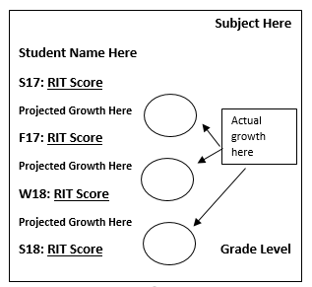
DATA CARD KEY
S17 | Spring 2017 RIT Score (if the student tested in Spring 2017)
F17 | Fall 2017 RIT Score
W18 | Winter 2018 RIT Score (if the student tested in Winter 2018)
S18 | Spring 2018 RIT Score
M/R/L/S | Indicates the subject area- Math, Reading, Language Usage, or Science
+5 | Indicate an increase in RIT score between test terms using a + and the number of RIT point increase.
-4 | Indicate a decrease in RIT score between test terms using a - and the number of RIT point decrease.

Step 4.  ADD STICKY DOTS | Identify the percentile of each student’s overall RIT score in the column marked Percentile Range on the Achievement Status and Growth Projection Report. Use the bolded number in the middle of the percentile range.  Place a sticky dot on each student’s data card to indicate if that student’s RIT score is in the Lo, LoAvg, Avg, HiAvg, or Hi percentile range. Use the scale below to do so. Make sure that you place the sticky dot next to the appropriate testing window. In future testing windows, you will update your data card with the students’ RIT score, and place new sticky dots on the card if the student’s performance has risen above or fallen below the grade level status norm. If you do not have sticky dots, you may use markers instead.  Lo %ile < 21 LoAvg %ile 21-40 Avg %ile 41-60 HiAvg %ile 61-80 Hi %ile >80
Step 5.  CREATE WALL | Place your student data cards in the RIT range on the data wall that corresponds to the RIT range listed on the data card for this testing period. Be sure to place your card in the appropriate grade level row. For example, a 3rd grade student with a RIT score of 185 would be placed in the space marked with an “X” on the sample data wall template on the next page.

SAMPLE DATA WALL TEMPLATE
 | 120-130 | 131-140 | 141-150 | 151-160 | 161-170 | 171-180 | 181-190 | 191-200 | 201-210 | 211-220 | 221-230 | 231-240 | 241-250 | 251-260 | 261-270 | 271-280 | 281-290
2
3 |  |  |  |  |  |  | X
4
5
6
7
8

Step 6.  DATA DIALOGUE | Participate in the Here’s What! So What? Now What? Data-Driven Dialogue with your colleagues. Your leader will explain this dialogue and provide some examples. Then you will break into pairs or trios with grade band peers to complete each column of the Here-So-Now graphic organizer. This will then lead into a full staff discussion of the data you see on your school MAP data wall.

