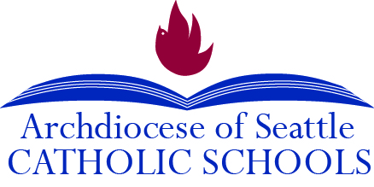

Recommended Practices for Engaging Catholic School Families in Parish Life

1. Children-Led Weekend Mass:
- Invite all school families to attend in school uniform
- Have a class a month host a weekend Mass.
- Students greet, do readings, bring up offering, usher, read prayers of the faithful*, read announcements, and pass out bulletins after Mass.

*When children are not yet reading, the adult can read and child can raise his/her hand for congregational response.

2. CLOW – Children’s’ Liturgy of the Word – Adult takes children out of mass to discuss in depth the weekly readings

3. School Children’s Choir – Students sing at weekend Mass, which increases school family attendance.

4. A class hosts donuts after weekend Masses.

5. Free Dress Pass for wearing uniform to weekend Mass. A school representative passes out the passes to students in school dress uniform at Mass.

6. Improve parish-school communication by including parish information in all school newsletters.

7. Add volunteer opportunities in parish for school volunteer hours. Communicate this in both church bulletin and all school newsletter.

8. Have students serve as altar servers at daily and weekend masses

9. Add Family Faith Formation Activities such as Lenten Fairs, Advent Festival, Yule Feast, Mardi Gras Celebration, and CCD (Sunday School)

10. Host a family night for singing Christmas carols with cookies for parish and school families.

