Post MAP Testing Individual Teacher Action Planning Protocol
Step 1.  PRINT REPORT | Login to the NWEA reports site: https://sso.mapnwea.org/auth/login. Download and print the NWEA Class Breakdown report for your students (View Reports → MAP Growth Reports → Class Breakdown). Make sure you specify the subject you will print, click Fall 2017-2018 for term rostered and term tested, and click by Goal before printing.  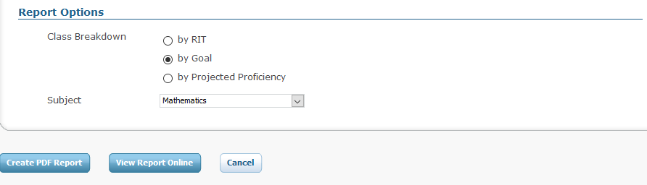
Step 2.  INDIVIDUAL REFLECTION | Review the Class Breakdown report individually, reflecting on these questions:  - Which students are below the student status norm RIT for this subject and testing period?  - At what RIT range(s) are most students performing? Is that RIT range above, below, or equal to the status norm RIT range for this subject and testing period?  - Which students might need individual interventions? These are students whose RIT scores fall far below or far above most of their peers.  - Who are your “almost there” kids? These are students who are approaching the grade level status norm.  - Are there any observable trends by goal area (ie is the class, on the whole, stronger in one goal area and weaker in another)?
Step 3.  GOAL SETTING | Consider the goals you already have in place at your school and in your classroom, and set a goal for class MAP performance.  Our School Learning Goal(s):  My classroom SMART Goal(s):  My class goal for MAP testing is:  __________% of students (or _______ of _______ students) will meet their projected RIT growth in Math/Science/Reading/Language (circle one) by the Winter/Spring (circle one) testing period.  AND/OR  ___________ students will move from below the grade level status norm in Math/Science/Reading/Language (circle one) by the Winter/Spring (circle one) testing period.  My MAP goal is related to my classroom SMART goal(s) because . . .
Step 4.  ACTION PLANNING: INTERVENTIONS | Create an intervention plan for students whose RIT scores fall far below or far above most of their peers. To determine the instructional needs of these students, it is best to access the Student Profile Report (View Reports MAP Growth Reports Student Profile). Be sure to choose the Fall 2017-2018 testing period when accessing this report. Once you access a particular student’s profile, you can choose the subject area you would like to focus on on the top of the screen. Then, review each instructional area and identify the skills that each student is ready to develop. In some cases, the Student Profile will provide a suggested area of focus, which will be indicated on the left side of the screen.  Your action plan for these students should address any major skill gaps, or any areas in which gifted students are excelling and are ready for new skills that have not yet been introduced to the rest of the class. Consider the following questions when designing your action plan:  - What are the major skills that require intervention?  - Are there non-academic skills that also should be addressed (behavioral, social-emotional)?  - Do the skill gaps require Tier 1 intervention (differentiated instruction in the classroom), Tier 2 intervention (small group instruction), or Tier 3 inervention (individualized, intensive instruction)?  - Who will provide the required interventions?  - Fow how long will the intervention be in place?  - How will intervention effectiveness be determined?  **You may wish to use the template provided to create your action plan, or you may wish to plan in your own way.  Refer to Appendices A & B for suggested intervention strategies
Step 5.  ACTION PLANNING: INSTRUCTIONAL GROUPING | Create an instructional grouping action plan. To determine instructional groups, it is best to review the Class Breakdown by Goal in conjunction with the Learning Continuum (View Reports MAP Growth Reports Learning Continuum). Look at the RIT ranges that students fall into and determine the skills that each group of students is ready to learn. Consider how you might flexibly group students using the information provided in the Learning Continuum. Consider the following questions when designing your action plan:  - What is the skill gap that you will prioritize? Why? For which students?  - What are the best grouping structures to teach the skills that you need to teach? You may wish to refer to Appendix A: Instructional Grouping Strategies, when considering which grouping structures are best for the different groups of students/skills you will be teaching.  - How can you use the information provided in the learning continuum to plan lessons in your upcoming unit(s)?  - When will you revisit these instructional groups? Will they change when new content (a new goal area) is covered?  **You may wish to use the template provided to create your action plan, or you may wish to plan in your own way.

