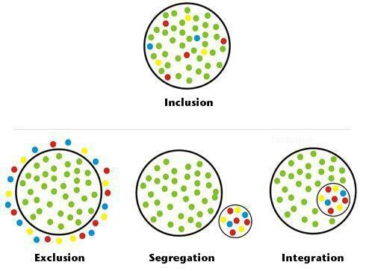

“Calling to mind the teaching of Saint Irenaeus that the glory of God is seen in a living human being, the Holy Father encourages all of you to let the light of that glory shine so brightly that everyone may come to recognize the inestimable value of all human life. Even the weakest and most vulnerable, the sick, the old, the unborn and the poor, are masterpieces of God’s creation, made in his own image, destined to live forever, and deserving of the utmost reverence and respect. His Holiness prays that the Day for Life will help to ensure that human life always receives the protection that is its due, so that 'everything that breathes may praise the Lord'”.

Pope Francis
July 17, 2013

