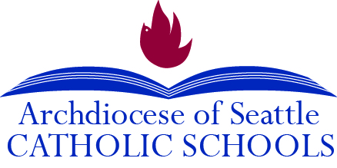

____________ 2020

Dear Parents:

If your child is not fluent in English or your home language is not English, we want to work with you to ensure that we are doing all we can to help your child(ren) succeed in school. One way we can do this is by taking advantage of the services that are available to English language learners through federal education programs. A portion of the funding for these programs comes from your hard-earned tax dollars!
In order to qualify for these programs, we will need to identify which children may need extra assistance in learning English. To help us do so, we ask that you kindly complete the following survey and return it to your child’s homeroom teacher no later than _______________________. Please note that this form will NOT be used to identify students who may be undocumented, and all information will remain confidential.
If you have any concerns or questions, please do not hesitate to reach out. You may also email Terri Fewel, Assistant Superintendent at the Office for Catholic Schools, at teresa.fewel@seattlearch.org.

Sincerely,

Principal

https://mycatholicschool.org
Resources for Educators and Parents

206-382-4861
1-800-473-5651
710 Ninth Avenue
Seattle, WA 98104
710 Ninth Avenue
Seattle, WA 98104
710 Ninth Avenue
Seattle, WA 98104

HOME LANGUAGE SURVEY

Student Name: |  |  |  | Date:
School:
Birth Date: | Gender: | Grade:
Form Completed by:
Parent/Guardian Name Relationship to Student
Parent/Guardian Signature

In what language(s) would you prefer to receive communication from the school?

- In what country was your child born? |  |  | _________________________
- What language did your child first learn to speak? |  |  | _________________________
- What language does YOUR CHILD use the most at home? |  |  | _________________________
- What is the primary language used in the home, regardless of the language spoken by your child? |  |  | _________________________
- Has your child received English language development support in a previous school? |  |  | Yes ________  No ________  Don’t Know ________
- Has your child ever received formal education outside of the United States? (Kindergarten – 12th grade)  _____Yes _____No |  |  | If yes, in what language(s) was instruction given? _____________________ For how many months? ____
- When did your child first attend a school in the United States? (Kindergarten – 12th grade) |  |  | _______________________  Month Day Year

This form has been adapted from the OSPI Home Language Survey. If an answer other than English is recorded for question 2 or question 3, the child should receive English language proficiency placement testing for Title III services to Catholic schools. This form is available in multiple languages at http://k12.wa.us/MigrantBilingual/HomeLanguage.aspx.

