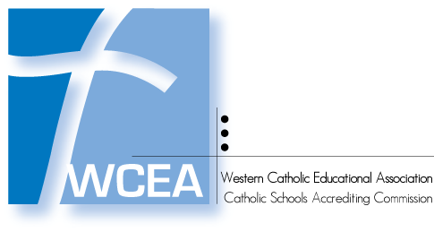

Visiting Committee Grant

2021-22 Application

WCEA sets aside funds annually to assist socio/economically-challenged schools in meeting their expenses incurred by the Visiting Committee of an accreditation visit. These funds are capped at $600. The original applications must be received by WCEA on or before **January 31st, 2021** via mail.

**WCEA Assistance Criteria:**

1. The school must have a scheduled accreditation full visit for the stated school year
2. The application packet must include the following:
   * the fully-completed application (no blank areas of information)
   * a written, signed letter from the WCEA Commissioner and Superintendent (if different than the WCEA Commissioner) that explains the rationale for the school's financial need of the WCEA Grant. This may be one letter with both signatures or two letters with one signature each.
   * written signatures only on this application (no digital signatures will be accepted)
3. The Grant Request Packet must be to WCEA’s office (address below) no later than **January 31, 2021**. No applications received after that date will be considered. Only fully-completed applications with all required information and the attachment(s) will be considered.

Amount Requested ($600 maximum): $ 

## **School Information**

|  |  |  |  |
| --- | --- | --- | --- |
| School Name |  | WCEA School Code |  |
| School Street Address |  | | |
| City, State, Zip |  | | |
| Principal Name |  | Contact Number |  |
| Principal Email |  | | |
| Percentage of students who qualify for federal free or reduced lunch | |  | |

## **Superintendent Information**

|  |  |  |  |
| --- | --- | --- | --- |
| Superintendent Name |  | Contact Number |  |
| Superintendent Email |  | | |

## **Signatures**

|  |  |  |  |  |
| --- | --- | --- | --- | --- |
| Principal Signature |  | | Date |  |
| Commissioner Signature | |  | Date |  |

**Mail the completed application and attached letter to: WCEA, 101 S Kraemer Blvd Ste 115, Placentia CA 92870**