WSCC 2021 Catholic Advocacy Bulletin, No. 20 July 15, 2021

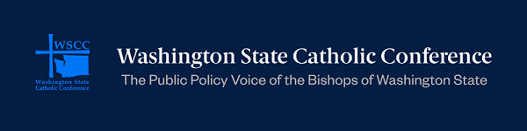

Survey: Share Your Advocacy Priorities With the Bishops
The Washington State Catholic Conference (WSCC) is the public policy voice of the bishops of Washington state, and the WSCC bishops would like to hear what your top Catholic advocacy priorities are. Participate in this brief survey to let the bishops know which policy priorities you are interested in advocating for. The survey takes only about two minutes to complete. This link may be shared with other members of the Catholic Church in Washington. Thank you for making your voice heard and for participating in the survey.

USCCB Petition and Action Alert to Support Pro-Life Policies
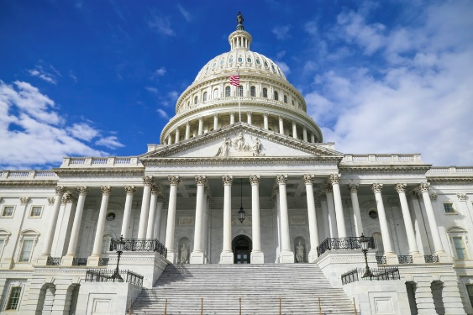
Sign this USCCB petition to tell Congress to refrain from using taxpayer money to fund abortions. The House Committee on Appropriations is currently marking up the Financial Services and General Government (FSGG) and State Foreign Operations (SFOPs) appropriations bills. These bills exclude longstanding provisions that prevent taxpayer funds from being used to pay for abortions. Archbishop Joseph Naumann, chair of the USCCB Committee of Pro-Life Activities, and Bishop David Malloy, chair of the USCCB Committee on International Justice and Peace, released a statement calling on the US House Appropriations Committee to refrain from eliminating provisions that prevent taxpayer funding of abortions. Additionally, you may use this USCCB Action Alert to urge your US Congress member and Senator Patty Murray and Senator Maria Cantwell to support longstanding, bipartisan pro-life policies. Check out these USCCB resources to learn more about preventing the use of taxpayer funds for abortions.

Invitation to the Cornerstone Catholic Conference

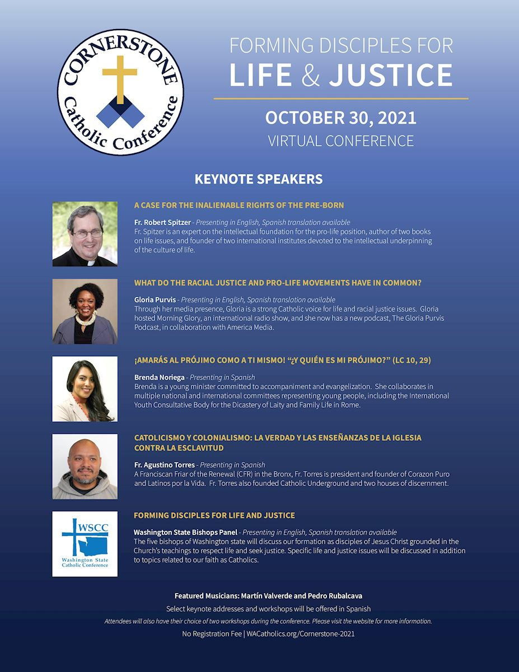
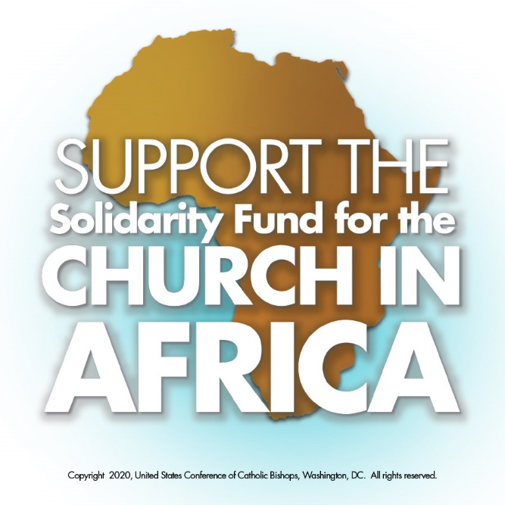

New USCCB Grants for Pastoral Work In Africa
Despite hurdles of poverty and political unrest affecting the Catholic Church in Africa, the Church has tripled in size in Africa in the past 30 years. To sustain this growth and expand pastoral outreach, the USCCB Subcommittee on the Church in Africa recently approved $1.36 million in grants for 56 pastoral projects in Africa. These grants are made possible through the generosity of Catholics contributing to the Solidarity Fund for the Church In Africa. Learn more here.

USCCB Calls for Christ-like Compassion in Response to Migrant Protection Protocols
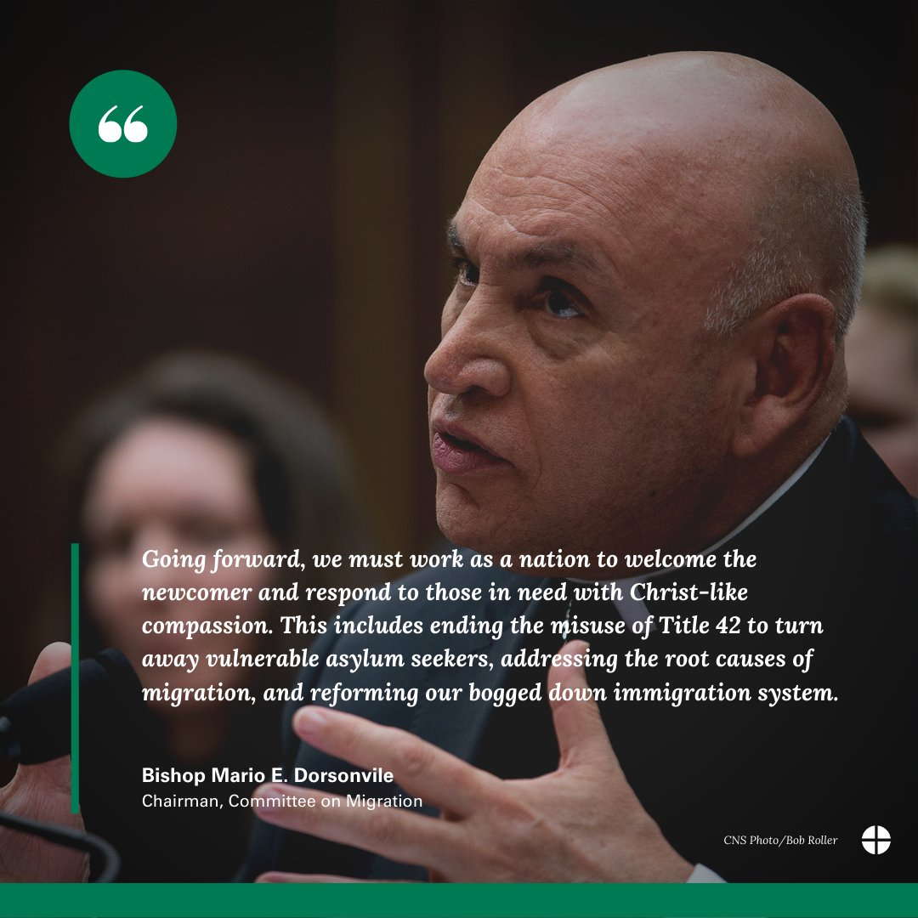
In 2019 the Trump administration implemented Migrant Protection Protocols (MPP), commonly known as the “Remain In Mexico” policy, whereby asylum seekers were returned to Mexico, facing dangerous and inhumane conditions as they awaited adjudication of their cases. The Biden administration ended this practice on June 1. Consequently, on June 21 the Supreme Court dismissed a case and denied a motion for another case challenging the now moot Migration Protection Protocols. The USCCB, Catholic Legal Immigration Network, and Catholic Charities USA filed an amicus curiae brief arguing that MPP is contrary to domestic and international law and contrary to Catholic social teaching, which calls for migrants to be welcomed and protected in accordance with their God-given dignity. In response to the Supreme Court decisions, Bishop Mario Dorsonville, chair of the USCCB Committee on Migration, issued a statement, “ . . . we must a work as a nation to welcome the newcomer and respond to those in need with Christ-like compassion. This includes ending the misuse of Title 42 to turn away vulnerable asylum seekers, addressing the root causes of migration, and reforming our bogged down immigration system.”

Catholic Schools

Join School Choice Efforts
Empower Washington is a cross-party movement working to put families at the center of our education system, giving families the power to decide how to spend education dollars. Empower Washington’s goal is to give families the opportunity to choose schools for their children, including Catholic schools. Visit their website or contact Quentin Orem at quentin@empowerwashington.org for more information.

WSCC Catholic Schools Newsletter
Supporting Catholic schools is one the legislative priorities of the bishops of Washington state. For more information about how the WSCC works for Catholic schools, you are invited to read our quarterly Catholic Schools Newsletter, designed for Catholic School parents, educators, families, and supporters.

WSCC Staff Update

A member of the WSCC staff for nearly three years, Tracey Wilson Yackley has assumed a new role as our Operations Manager. In addition to administrative and compliance functions, Tracey has now taken on larger roles in the planning and management of special projects and events and in social media and communications. The WSCC is thankful for the many talents Tracey brings to our team!

Important Dates
Sept 1 World Day of Prayer for the Care of Creation
Sept 15 National Hispanic Heritage Month begins (ends October 15)
Sept 20 National Migration Week begins
Sept 26 World Day of Migrants and Refugees
October 30 Virtual Cornerstone Catholic Conference

WSCC Staff
We invite you to contact us at any time.
Mario Villanueva, Executive Director
mario.villanueva@wacatholics.org

Adrienne Corpuz Joyce, Director of Policy and Communications
adrienne.joyce@wacatholics.org

Tracey Wilson Yackley, Operations Manager
tracey.yackley@wacatholics.org

Did a relative or friend forward this WSCC Catholic Advocacy Bulletin to you? Sign up for your own free subscription here. The bulletin is available in both Spanish and English.
You can also find the Washington State Catholic Conference on Facebook, Twitter @wacatholics, and Instagram.
Click here to view previous WSCC bulletins on our website.

