**WSCC 2022 Catholic Advocacy Bulletin, No. 9 March 21, 2022**

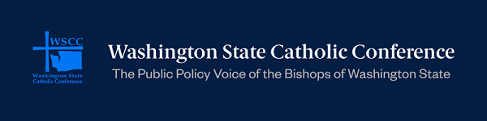

**Getting Bills To The Finish Line**

**Action Alert: Urge Governor Inslee To Take Action On These Bills**

**The governor’s desk is the final stop for bills before they become law. The legislative session ended on Thursday, March 10, and all viable bills have now been delivered to Governor Jay Inslee. He may now choose to veto or partially veto bills, sign them into law, or do nothing. If the governor does not take action on a bill it will automatically become law. Governor Inslee has until April 2 to take action on bills that are still viable. Now is the time to urge the governor to take action on bills related to the bishops’** [legislative priorities](https://www.wacatholics.org/stay-informed/wscc-2021-legislative-priorities)**.**

[Send a message](https://www.governor.wa.gov/contact/contact/send-gov-inslee-e-message) **to Governor Inslee to sign the following bills into law: HB 1412, HB 1616, HB 1643, HB 1646, HB 1723, HB 1724, HB 1725, HB 1748, HB 1753, HB 1833, HB 1860, HB 1866, HB 1888, HB 1905, SB 5268, SB 5532, SB 5566, SB 5610, and SB 5745. Details of these bills are listed below. Thank you for your advocacy!**

**Modifying Legal Financial Obligations (LFOs)**

[House Bill 1412](https://app.leg.wa.gov/billsummary?BillNumber=1412&Initiative=false&Year=2021) **(HB 1412)**

**HB 1412 modifies legal financial obligations (LFOs). When a defendant is convicted of a crime, the court may impose legal financial obligations as part of its judgment and sentence. Examples of LFOs include victim restitution, crime victims’ compensation fees, and costs associated with the offender’s prosecution and sentence. Because formerly incarcerated individuals are often impoverished, it is difficult to pay LFOs. HB 1412 sets a standard of indigency to determine if offenders have an inability to pay for LFOs. The bill also allows courts to not impose restitution or to waive full or partial restitution if an offender does not have the current or likely future ability to pay LFOs. In line with the bishops’ restorative justice and economic justice legislative priorities, the WSCC supports HB 1412.**

**Expanding the Charity Care Act**

[House Bill 1616](https://app.leg.wa.gov/billsummary?BillNumber=1616&Initiative=false&Year=2021) **(HB 1616)**

**HB 1616 increases the number of individuals eligible for charity care at hospitals. In accordance with the bishops’ hospitals and health care and economic justice legislative priorities, the WSCC supports the Charity Care Act.**

**Exempting Affordable Housing From the Real Estate Excise Tax**

[House Bill 1643](https://app.leg.wa.gov/billsummary?BillNumber=1643&Initiative=false&Year=2021) (HB 1643)

HB 1643 will exempt the sale or transfer of property to a nonprofit, housing authority, public corporation, county, or municipal corporation from the real estate excise tax if the grantee intends to use the property for rental housing for low-income persons. In line with the bishops’ affordable housing legislative priority, the WSCC supports HB 1643.

**Closing the Digital Equity Divide**

[House Bill 1723](https://app.leg.wa.gov/billsummary?BillNumber=1723&Year=2021&Initiative=false) (HB 1723)

Our society is increasingly dependent on digital connectivity. However, many residents living in rural or underserved areas or of modest income do not have access to quality broadband internet service. HB 1723 provides low-income individuals with reduced rates for eligible voice and broadband services. It also provides discounted rates for telecommunications services and infrastructure costs to institutions such as public schools, libraries, early learning centers, homelessness shelters, community centers, and other nonprofit or governmental community support organizations. On January 27 WSCC Executive Director, Mario Villanueva, testified in support of HB 1723. View his testimony [here](https://www.tvw.org/watch/?clientID=9375922947&eventID=2022011548&startStreamAt=4729). In accordance with the bishops’ economic justice legislative priority, the WSCC supports HB 1723.

**Housing Opportunities For People with Disabling Conditions**

[House Bill 1724](https://app.leg.wa.gov/billsummary?BillNumber=1724&Initiative=false&Year=2021) (HB 1724)

HB 1724 creates a permanent supportive housing advisory committee that will provide advice, recommendations, stakeholder engagement, and oversight of resource coordination to bring high quality, permanent, supportive housing to scale for individuals with disabling conditions. In line with the WSCC’s legislative priorities of affordable housing and caring for the aging and those with disabilities, the WSCC supports HB 1724.

**Endangered Missing Person Advisory Designation for Indigenous Persons**

[House Bill 1725](https://app.leg.wa.gov/billsummary?BillNumber=1725&Initiative=false&Year=2021) (HB 1725)

HB 1725 creates an endangered missing person advisory designation for missing indigenous persons. Indigenous people experience disproportionate rates of violence in Washington state. To address the crisis of missing and murdered indigenous people, HB 1725 creates a special alert for missing indigenous women and persons. This alert is akin to amber alerts designated for missing children. In accordance with the legislative priority to respect the dignity of life, the WSCC supports HB 1725.

**Eligibility Of Victims of Human Trafficking for Assistance Programs**

[House Bill 1748](https://app.leg.wa.gov/billsummary?BillNumber=1748&Initiative=false&Year=2021) (HB 1748)

HB 1748 assists victims of human trafficking by establishing their eligibility for the Housing and Essential Needs (HEN) program and the Aged, Blind, or Disabled (ABD) program. HEN and ABD provide cash assistance to eligible individuals in need. This bill is in line with the bishops’ legislative priority of respecting life, and the WSCC supports HB 1748.

**Tribal Consultation and the Climate Commitment Act**

[House Bill 1753](https://app.leg.wa.gov/billsummary?BillNumber=1753&Year=2021&Initiative=false) (HB 1753)

Under HB 1753, state agencies must offer early, meaningful, and individual consultation with any federally recognized tribes affected by Climate Commitment Act programs that may impact tribal resources such as tribal cultural resources, fisheries, and archaeological sites. In accordance with the bishops’ legislative priorities to respect the life and dignity of all and to care for God’s creation, the WSCC supports HB 1753.

**Electronic Enrollment System For the National School Lunch And Breakfast Programs**

[House Bill 1833](https://app.leg.wa.gov/billsummary?BillNumber=1833&Initiative=false&Year=2021) (HB 1833)

**HB 1833 creates a statewide electronic system for enrollment in the National School Lunch Program and the School Breakfast Program.** The electronic system created by HB 1833 will determine students’ eligibility for free and reduced-price meals in lunch and school breakfast programs. This will increase program participation by families in need. It will also ease schools’ applications for schoolwide free meals; entire schools are eligible for free meals when at least 40% of its students are eligible for free lunch and breakfast programs. In accordance with the bishops’ legislative priorities of economic justice and supporting children and families, the WSCC supports HB 1833.

**Preventing Homelessness Among Persons Discharged From Behavioral Health Settings**

[House Bill 1860](https://app.leg.wa.gov/billsummary?BillNumber=1860&Initiative=false&Year=2021) (HB 1860)

HB 1860 prevents homelessness among persons discharged from behavioral health settings. Per HB 1860, when the Health Care Authority contracts with a Managed Care Organization, the Managed Care Organization will be required to provide housing-related care coordination services for enrollees who are discharged from inpatient behavioral health settings. Discharge is a pivotal point in a person’s treatment or recovery, and stable housing is a necessity to continued successful treatment and good health. In accordance with the bishops’ legislative priority focusing on health care, the WSCC supports HB 1860.

**Helping Medicaid Recipients Receive Housing and Community Supports**

[House Bill 1866](https://app.leg.wa.gov/billsummary?BillNumber=1866&Year=2021&Initiative=false) **(HB 1866)**

**HB 1866 establishes the Apple Health and Homes Program, which will provide a supportive housing benefit and community support services to low-income individuals who have medical risk factors and encounter barriers to finding stable housing. In line with the bishops’ health care and affordable housing legislative priorities, the WSCC supports HB 1866.**

**Improving the Working Families Tax Credit**

[House Bill 1888](https://app.leg.wa.gov/billsummary?BillNumber=1888&Year=2021&Initiative=false) **(HB 1888)**

**In 2021 the legislature voted to fund the Working Families Tax Credit, a tax credit that assists low-income, working individuals and families.** The Working Families Tax Credit addresses Washington's regressive tax system, which causes low-income Washingtonians to pay a higher percentage of their household income in comparison to wealthier residents. HB 1888 improves the Working Families Tax Credit by aligning rates with federal maximum qualifying income levels. In accordance with the bishops' legislative priority of economic justice, the WSCC supports HB 1888.

**Reducing Youth and Young Adult Homelessness**

[House Bill 1905](https://app.leg.wa.gov/billsummary?BillNumber=1905&Year=2021&Initiative=false) (HB 1905)

HB 1905 establishes a rapid response team to support youth and young adults exiting publicly funded care, including the child welfare system, behavioral health system, juvenile justice system, and programs administered by the Office of Homeless Youth Prevention and Protection Program. Young individuals exiting these programs are at a high risk for experiencing homelessness. The rapid response team: will be comprised of representatives from relevant state agencies, will connect youth and young adults with support services, and will help clients to secure appropriate housing. In line with the bishops’ children and families and affordable housing legislative priorities, the WSCC supports HB 1905.

**Improving Services For Individuals With Intellectual and Developmental Disabilities**

[Senate Bill 5268](https://app.leg.wa.gov/billsummary?BillNumber=5268&Year=2021&Initiative=false) **(SB 5268)**

**SB 5268 increases the capabilities of community residential settings and redesigns intermediate care facilities. This is a landmark bill to improve services for individuals with disabilities. In line with the bishops’ legislative priority to care for the aging and those disabilities, the WSCC supports SB 5268.**

**Increasing the Personal Needs Allowance For Medicaid Recipients**

[Senate Bill 5745](https://app.leg.wa.gov/billsummary?BillNumber=5745&Initiative=false&Year=2021) (SB 5745)

SB 5745 increases the personal needs allowance to a more sustainable level. Federal law requires that Medicaid recipients contribute to the cost of their long-term care. In calculating their contribution, a personal needs allowance may be deducted. The current personal needs allowance is too small, amounting to $1,045 per month for a single person to cover rent, food, and other costs. A higher personal needs allowance gives seniors the opportunity to choose to stay in their homes and receive care, rather than move to more expensive facilities. Washington currently only allows personal needs allowances to equal 100% of the federal benefit rate, but other states allow for a personal needs allowances equaling 300% of the federal benefit rate. Catholic Community Services’ Peter Nazzal, Director of Long Term Care, testified in favor of HB 5745. In line with the bishops’ legislative priorities of economic justice and caring for the aging and disabled, the WSCC supports SB 5745.

**Diaper Subsidies For TANF Recipients**

[Senate Bill 5838](https://app.leg.wa.gov/billsummary?BillNumber=5838&Year=2021&Initiative=false)(SB 5838)

TANF provides temporary cash assistance, subsidized childcare, and work programs for low-income households with children.  SB 5838 authorizes additional monthly payments to TANF recipients with children under the age of three to cover child-related necessities such as diapers.  Aleah Patulot, director of Pregnancy and Parenting Support (PREPARES) for Catholic Community Services of Western Washington, testified at the January 21 Senate hearing for SB 5838.  In line with the bishops' children and families and economic justice legislative priorities, the WSCC supports SB 5838.

**Good News: Bills Signed Into Law**

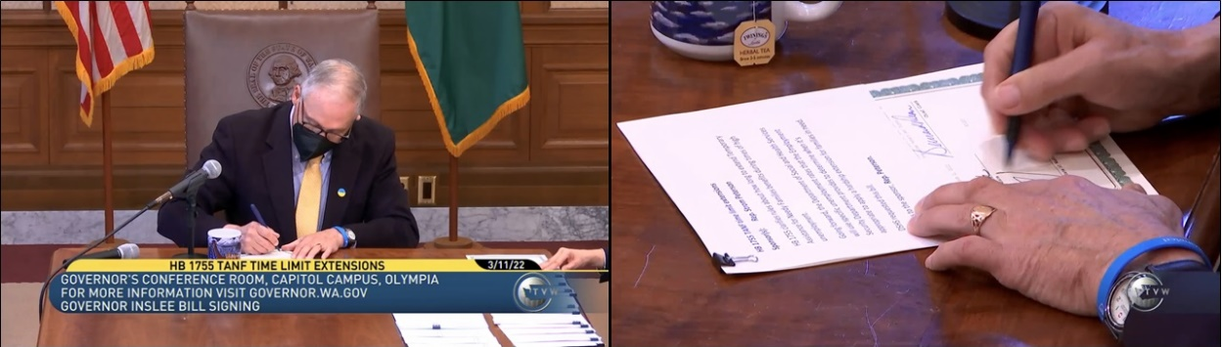**TANF Time Limit Extensions**

On March 11 Governor Inslee signed [House Bill 1755](https://app.leg.wa.gov/billsummary?BillNumber=1755&Initiative=false&Year=2021) (HB 1755) into law. HB 1755extends the time limits of the Temporary Assistance for Needy Families (TANF) program. TANF provides temporary cash assistance, subsidized childcare, and work programs for low-income families. There is a five-year time limit to receiving TANF. HB 1755 extends the time limits of this program to account for hardship experienced during the pandemic. The extension goes into effect when the state unemployment rate is 7% or higher. In accordance with the bishops’ economic justice legislative priority, the WSCC supports HB 1755.

**Human Trafficking and Commercial Drivers Licenses**

On March 11 Governor Inslee signed [Senate Bill 5631](https://app.leg.wa.gov/csi/Testifier/Add?chamber=House&mId=29800&aId=146424&caId=19527&tId=3) (SB 5631) into law. SB 5631 addresses human trafficking by commercial drivers and disqualifies a person convicted of human trafficking offenses from holding a commercial driver license for life. Human trafficking often involves the use of commercial vehicles. In accordance with the bishops’ legislative priority to respect the life and dignity of all, the WSCC supports SB 5631.

**Additional Bill Updates**

**Climate Change Bill Dies In House**

[House Bill 1099](https://app.leg.wa.gov/billsummary?BillNumber=1099&Year=2021&Initiative=false) (HB 1099) improves the state's climate response. The House and Senate passed different versions of the bill, so HB 1099 was sent to a conference committee during the final week of the session. The Senate approved the conference committee report, but House opponents to the bill ultimately prevented it from being passed. Consequently, HB 1099 died. HB 1099 updates the Growth Management Act, the state's comprehensive planning framework.  The bill calls for cities and counties to upgrade their land use and transportation planning to reduce greenhouse emissions.  Additionally, this bill embeds a definition for environmental justice into the Growth Management Act.  Environmental justice is defined as the fair treatment and meaningful involvement of all people, regardless of race, color, national origin, or income with respect to development, implementation, and enforcement of environmental laws, regulations, and policies.  This bill is in line with the bishops' legislative priority to Care for God's Creation, and the WSCC supports HB 1099.

**Assisted Suicide Bill Fails To Pass Out Of Committee**

Thank you for your advocacy! The assisted suicide bill, [House Bill 1141](https://app.leg.wa.gov/billsummary?BillNumber=1141&Initiative=false&Year=2021) **(HB 1141),** failed to pass out of the Senate Committee on Health and Long Term Care. The bill is now dead for this session. In 2008 Washington voters approved Initiative 1000, the Physician-Assisted Death Initiative, but only after being assured that certain "safeguards" would be in place. HB 1141 loosens safeguards, increasing access to physician-assisted suicide and accelerating the process.  The bill broadens the definition of a "qualified medical provider" who can make a diagnosis and prescribe lethal medication. Two physicians are no longer required to diagnose a patient. HB 1141 also loosens the definition of those who can provide counseling; in lieu of a psychiatrist or psychologist, a social worker, mental health counselor, or psychiatric advanced nurse practitioner may determine if a patient is suffering from a psychiatric or psychological disorder or depression causing impaired judgement.  Additionally, this bill shortens the minimum amount of time from 15 days to just 72 hours that a patient is required to wait between making a request and receiving a prescription to terminate his or her life. The 72 hour wait time may even be waived if the "qualified medical provider" deems that a patient has less than 72 hours to live.  HB 1141 also permits assisted suicide prescriptions to be delivered via the mail. In accordance with the bishops' legislative priority to respect life, the WSCC opposes HB 1141.

**Assisted Suicide Study Added to Budget Bill**

**Although the assisted suicide bill died during the session, in the last two weeks of the legislative session a budget proviso was added to the Operating Budget (**[House Bill 5693](https://app.leg.wa.gov/billsummary?BillNumber=1181&Year=2021&Initiative=false)**) for “A Study of the Death With Dignity Act.” Unfortunately, this University of Washington study is framed in a biased way to increase assisted suicide. Instead of studying the effects of the Death With Dignity Act objectively, the purpose of the study is to** “review the extent to which there are barriers to achieving full access to the Washington death with dignity act.” Voter-approved safeguards to assisted suicide are characterized as barriers. This budget proviso mirrors an assisted suicide bill that was passed in 2020 but vetoed due to COVID-19 budget cuts. The WSCC opposes this biased assisted suicide study.

**2022 Legislative Session**

Visit this section of our [website](https://www.wacatholics.org/be-an-advocate/current-legislation) to see the full list of bills the WSCC worked on and monitored during the 2022 session.

**Useful Links For the Legislative Session**

[Legislative Priorities of the Washington State Catholic Conference](https://www.wacatholics.org/stay-informed/wscc-2021-legislative-priorities)

[Identify your district and legislators](https://app.leg.wa.gov/districtfinder)

[Contact Governor Inslee](https://www.governor.wa.gov/contact/contact/send-gov-inslee-e-message)

[Washington State Legislature](https://leg.wa.gov/House/Committees/HCW/Pages/MembersStaff.aspx) **– Information on bills, hearings, legislators, and more**

[Find bill information](https://app.leg.wa.gov/billinfo/)

[WSCC website](https://www.wacatholics.org/)

**From the US Conference Of Catholic Bishops (USCCB)**

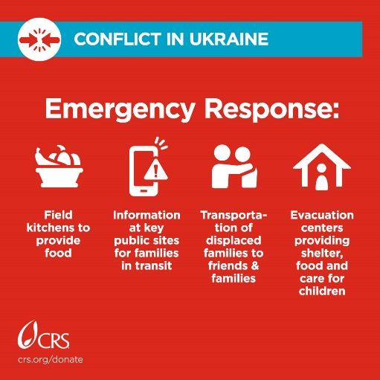

**Ukraine: Informational Resources And How To Help**

**See the USCCB’s Justice For Immigrants** [page](https://justiceforimmigrants.org/ukraine/) **to learn more about the invasion into Ukraine and how the Catholic Church is responding. For example, Catholic Relief Services (CRS) is working to aid those impacted by the invasion of Ukraine. Learn more about their efforts and how you can help** [here](https://support.crs.org/donate/donate-ukraine?ms=somtwi0522ukr00gen00&utm_source=communications&utm_medium=social&utm_campaign=2022-ukraine)**. Additionally, Catholic News Service (CNS) released this** [article](https://www.catholicnews.com/update-where-to-give-to-help-ukraine/?fbclid=IwAR3KRtFw0_Vu_JrJJ4r87MVzxFjK1Igyd7D9yYtnaqbBCYl9zZsHDiJFzSQ) **naming other organizations assisting with humanitarian efforts.**

**Seattle Catholic Men’s Conference**

Click [here](http://www.seattlemensconference.org/) to learn more about Seattle Catholic Men’s Conference. A conference in Spanish will be held May 7.

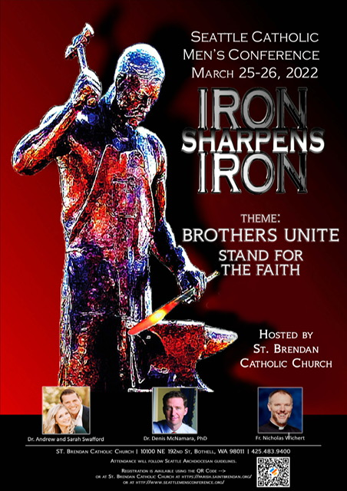

**WSCC Staff**

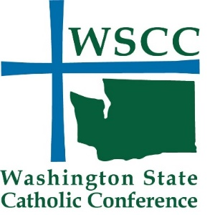 We invite you to contact us at any time.

**Mario Villanueva**, Executive Director

mario.villanueva@wacatholics.org

**Adrienne Corpuz Joyce**

Director of Policy & Communications

adrienne.joyce@wacatholics.org

**Tracey Wilson Yackley**, Operations Manager

tracey.yackley@wacatholics.org

Did a relative or friend forward this WSCC Catholic Advocacy Bulletin to you? Sign up for your own free subscription [here](https://www.votervoice.net/WSCC/Register). The bulletin is available in both Spanish and English.

You can also find the Washington State Catholic Conference on Facebook, Twitter @wacatholics, and Instagram.

Click [here](https://www.votervoice.net/WSCC/newsletters) to view previous WSCC bulletins on our website.

