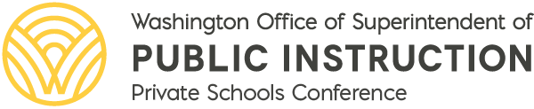

Neural Education: Unite the Neuroscience of Learning with the Art of Teaching
Presented by Dr. Kieran O’Mahony, Dr. Missy Widmann, and the Neural Education Champions.
The field of Educational Neuroscience is exploding and K-12 educators can now leverage new discoveries in neuroscience, growing their pedagogical practices and increasing student engagement and achievement. During this two-day conference, we will translate neuroscience research and brain-aligned strategies into the classroom, resulting in improved educational outcomes for all students, empowering all learners to access their full potential. Beginning with a foundational understanding of the structures of the brain and the impacts of stress and trauma on learning, we will then explore the possibilities of neurodiversity and neurodivergent affirming supports. During the closing session of the conference, teams will work collaboratively to integrate neuroscience into their learning spaces.

Agenda - Unite the Neuroscience of Learning with the Art of Teaching

August 3 & 4
Live virtual workshop
9 am–4 pm
Register

August 14 & 15
(Live repeat of the first virtual workshop)
9 am–4 pm
Register

Each Training
• Will be FREE to private school educators employed by State Board of Education approved private schools.
• Will have all training materials provided.
• Qualifies for FREE clock hours!

Registration - Open Now
For more information please contact: Allegra Antwine. The Agency TTY number is 360-664-3631.
This conference is provided in compliance with the requirement in the Elementary and Secondary Education Act (ESEA) section 8501(a)(4)(A) to provide equitable services to private school educators.

ALL STUDENTS PREPARED FOR POST-SECONDARY PATHWAYS, CAREERS, AND CIVIC ENGAGEMENT.  Led by State Superintendent Chris Reykdal, OSPI oversees K-12 public education in Washington state. Our mission is to provide funding, resources, tools, data and technical assistance that enable educators to ensure students succeed in our public schools, are prepared to access post-secondary training and education, and are equipped to thrive in their careers and lives. |  | 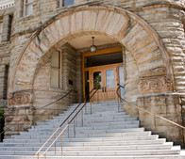

OSPI provides equal access to all programs and services without discrimination based on sex, race, creed, religion, color, national origin, age, honorably discharged veteran or military status, sexual orientation, gender expression, gender identity, disability, or the use of a trained dog guide or service animal by a person with a disability. Questions and complaints of alleged discrimination should be directed to the Equity and Civil Rights Director, P.O. Box 47200, Olympia, WA 98504-7200, 360-725-6162 (TTY: 360-664-3631), equity@k12.wa.us.
This Institution is an Equal Opportunity Provider.

