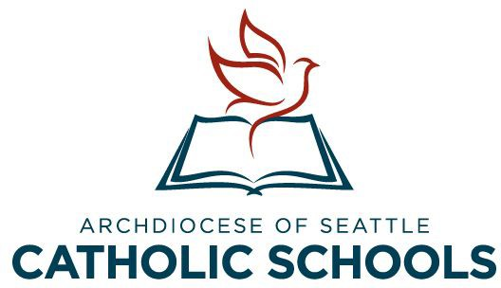
Office for Catholic Schools
Archdiocese of Seattle

Ministry Reference Cover Letter

Dear Pastor, Priest, Religious or Lay Religious Leader,

The person who has given you this reference form is an applicant for a school principalship in the Catholic Schools of Western Washington and has indicated that you are in a position to give us a reliable evaluation of their active participation in the practice of their faith.

The Catholic school strives to be a Catholic educational community and depends on the Catholic leadership qualities of the principal to reach this goal. Because this leadership responsibility is a serious one, we appreciate your candid opinion of this applicant.

No applicant will be eliminated on the basis of a single reference. Recommendations will be obtained from several sources. Prompt return of the reference will be most appreciated.

Please email your reference to Pam Schwartz
Assistant Superintendent, Personnel
Office for Catholic Schools
pam.schwartz@seattlearch.org
206-790-1925

Thank you for your assistance. Sincerely,
Nicholas Ford
Superintendent for Catholic Schools
Phone:206-382-4861
Fax: 206-654-4651
Email: Nicholas.Ford@seattlearch.org

Note to the Recommender:
Be aware that the recommendation you provide will be made available to the search committees of schools where the applicant is seeking employment. It will not be made available to anyone else, even at the request of the applicant or the recommender. The applicant may have access to your recommendation if he/she has not waived the right of access on the top of the Reference Form.

Office for Catholic Schools
Archdiocese of Seattle
Ministry Reference Form

To be completed by a person serving in a ministerial position in a parish/church or Catholic school.

Applicant’s Name: Applying for a position as
With reference to the Family Education Rights and Privacy Act of 1974:
I waive my viewing option I claim my viewing option to my recommendations.
Applicant’s Signature: Date:

Ministry Reference
Name:

Title:

Address: City: State: Zip Code:

The applicant whose name and signature appear above has given your name as a reference. Please answer the following questions to the best of your knowledge.
- How long have you known the applicant and in what ministerial relationship?

- To your knowledge is the applicant a participating member of his/her religious community/parish? Yes No
- Does the applicant have any limitation which you would consider to interfere with the regular duties of a principal in a religious school? If so, please note:

- Would you employ this candidate as the faith leader in a Catholic school? Yes No
- Any additional comments would be appreciated (e.g., listing strengths and weaknesses concerning this applicant.)

Attributes | Excellent | Good | Below Average | No opportunity to observe
Knowledge of Catholic Faith
Practices of Catholic Faith
Understanding of Catholic philosophy of education

- Do you have knowledge of any behavior that shows this applicant is not reliable, honest or of good character? Yes No If yes, please explain:

Overall recommendation for Principal/President in the Seattle Archdiocese:
I recommend the applicant without reservation.
I have some reservations, but would recommend the applicant.
I have substantial doubts, but think the applicant might be given a chance to prove himself/herself.
I feel the applicant is unsuited for school administration.
Please comment if an explanation would help the committee better understand this applicant’s skills.

Signature: Date: Title:
Email: Phone:

Please email directly to:

Pam Schwartz
Assistant Superintendent, Personnel
Office for Catholic Schools
pam.schwartz@seattlearch.org
206-790-1925

