Christ in the Classroom Foundation

“The Sacramental Nature of Catholic Schools”
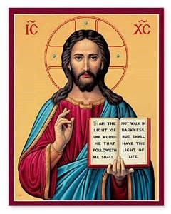

Task 2: Initiating into the Celebration of the Mystery

Christ in the Classroom Foundation Program Description

Catechesis, the “echoing” or passing on of our Catholic faith is designed to form disciples of Jesus Christ. Jesus formed his disciples through instructing, celebrating, witnessing, praying, living in community with others, and sharing the Good News of the Kingdom of God. Thus, we too are called to share the richness of faith through diverse, yet interrelated tasks.

Our Christ in the Classroom Foundation Retreats focus on the Catholic intellectual tradition and empower participants to thoughtfully share our Catholic faith with students and their families in meaningful and engaging ways. The retreats explore the Tasks of Catechesis: Leading to Knowledge of the Faith, Initiating into the Celebration of the Mystery, Forming for Life in Christ, Teaching Prayer, and Introduction to Community Life. Each task helps us deepen our personal relationship with Christ and forms us as missionary disciples. Knowing Jesus calls us to celebrate this relationship and also reminds us of the need for ongoing conversion, which leads to prayer, recognizing the needs of others, and realizing how we are called to share the Good News through word and deed.

The retreat presenters provide a framework for reflection and formation in Church teachings and documents that inform the Tasks of Catechesis through utilizing reflective journaling, small group discussion and large group sharing. Participants will gain insights for classroom application of retreat content from the presenters and each other in this collaborative retreat environment. We are blessed to serve together in the vital ministry of Catholic education, including the significant responsibility of guiding families toward the faith. Ultimately, the retreat encourages all participants to reflect deeply on the introductory statement in their covenant,

“The teacher agrees to respect Catholic values and to aid students in Christian formation by exemplifying Catholic living, both in and out of the classroom. Catholic schools educate their pupils to promote efficiently the good of the earthly city, and prepare them for the service of spreading the kingdom of God, so that by the exercise of an exemplary and apostolic life they may become, as it were, the saving leaven of human society. Bound by love to each other and to their pupils and imbued with the apostolic spirit, administrators and teachers bear witness by their life and teaching to the one teacher Christ (Gravissimum Educationis 8). This is the spirit that characterizes the covenantal relationship between the employer and the employee in the Catholic school”.

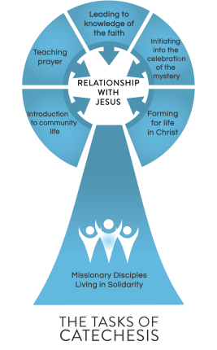

“Other realities were born of a charism: the charism of a founder or a founding group, or a charism inspired by that of a religious Institute. This too is an essential dimension of the Church’s life. I would like to invite you to consider charisms in relation to grace, to the gift of the Spirit. The Letter Iuvenescit Ecclesia, as you know, states that the ecclesiastical hierarchy and the sacrament of Holy Orders exist precisely so that “the objective offer of grace” made through “the sacraments, the normative proclamation of the word, and pastoral care” may always remain alive and present among the faithful (No. 14). Charisms, on the other hand, “are freely distributed by the Holy Spirit so that sacramental grace may bear fruit in Christian life in different ways and at every level”.
Consequently, everything in the Church is understood in reference to grace: the institution exists so that grace may always be offered, and charisms are given so that this grace may be received and bear fruit. Without charisms, there is a risk that Christ’s grace, offered in abundance, may not find good soil to receive it. That is the reason why God raises up charisms: to awaken in hearts a desire to encounter Christ and a thirst for the divine life that he offers us. In a word, grace!”
Address of His Holiness Pope Leo XIV to the moderators of lay associations, ecclesial movements, and new communities – June 6, 2025

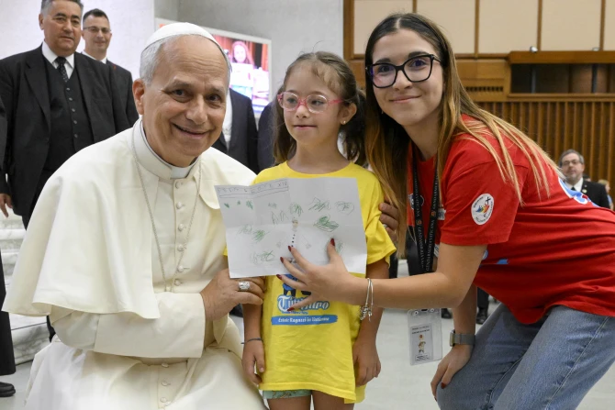

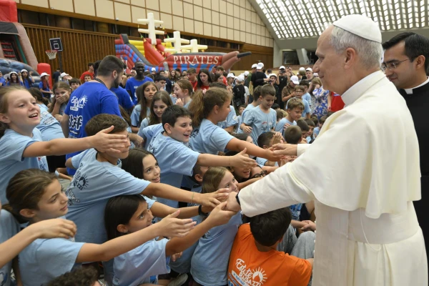

CIC Retreat Program Outcomes

KNOWLEDGE
Participants will:

- Know that a sacrament as an efficacious sign of grace instituted by Christ.

- Know how our Catholic schools are sacramental communities.

- Know that the life of the Christian involves ongoing and lifelong formation as a disciple of the Lord, flowing from the grace of Baptism and the sacramental life of the Church, following the catechumenal model as a member of the Church.

SKILLS
Participants will:

- Understand how to utilize sacramentals in one’s teaching and the learning environment.

- Bring people to know, love and obey Jesus Christ as the definitive aim of all catechesis.

- Act with confidence in the grace God gives through the Sacraments.

VALUES
Participants will:

- Experience and appreciate the richness of the Catholic Tradition.

- Embrace silence as a vehicle for reflection, prayer, and community-building.

- Contribute to a culture of prayer.

Task 2: Initiating into the Celebration of the Mystery

Students recognize the presence of Christ and enter into communion with Him through active, full and conscious participation in the Liturgical celebrations and Sacraments of the Church.

• Understand, live and bear witness to the suffering, death and resurrection of Jesus
• Understand Church Doctrine on the Eucharist and the other Sacraments
• Acquire the spirituality, skills and habits of full, conscious, and active participants of liturgy
• Value the dignity and responsibility of our baptism

Christ in the Classroom Introduction

Notes

Notes
Session 1: What is a Sacrament?

Journaling & Reflection
What rituals exist in your school that remind the community that the work you do is sacramental?

Journaling & Small Group Discussion (pick one)
- What in this presentation about sacraments resonated with you?
- Identify 1-2 things you could do to ‘ritualize’ and remind the community of the sacred work you do at your school.
- Call to mind 2-4 students, staff members, and/or parents in your community who exemplify this notion that the work we do is grace-filled and spend this time in gratitude for them.
Action Planning
CIC applications back to your school community.

Session 2: Community as Sacramental

Notes

Journaling & Reflection
What are the obstacles to establishing and maintaining sacramental, grace-filled communities? What might be some ways to overcome these obstacles?

Journaling & Small Group Discussion (pick one)
- What in this presentation about community as sacramental resonated with you?
- Reflect on 2-3 things your school does particularly well to build community. What specific effect(s) do these things have on your community?
Action Planning
CIC applications back to your school community.

Session 3: Symbols & Icons

Notes

Journaling & Reflection
Who at your school or in your vocational journey embody the sacramental nature of your community?
Journaling & Small Group Discussion (pick one)
- What in this presentation about symbols and icons resonated with you?
- Identify 1-2 programs or processes that are unique to your school. How are they ‘iconic’?

Action Planning
CIC applications back to your school community.

Session 4: The Role of Prayer

Notes

Journaling & Reflection
What kind of prayer ‘works’ for you? How do you pray? Why do you pray? How does it function in your life?

Journaling & Small Group Discussion (pick one)
- What in this presentation about “The Role of Prayer” resonated with you?
- What role does prayer play in your personal & professional life?
- In what ways might you invite/encourage more prayer in your school community?
Closing Questions
What are your takeaways from this retreat? How will you use this Christ in the Classroom Foundation program in your school?



CIC Retreat Evaluation:



For more information on the CIC program, please contact:
Connor Geraghty
(206) 382-4842
connor.geraghty@seattlearch.org

